Chapter 2: Review of Related Literature

Chapter 2: Review of Related Literature

2.1 Introduction
This chapter reviews the literature defining the scope of this thesis and introduces the components of the proposed solution. The review is organized around the structure of the problem itself. It first establishes the limits of current approaches, describes the phenomenon that undermines them, and then introduces the components needed to resolve these limitations. Five thematic areas trace this progression. Legacy font recognition, OCR/Layout and Closed-Set Vector assumptions reviews visual font recognition, the paradigm this work challenges. Traditional methods including DeepFont, classical OCR, Layout analysis, and attention-based localization rely on a closed-set, rigid-glyph assumption. However, generative AI text violates this assumption. Generative AI typographic hallucinations and diffusion latent mutations details these violations, specifically the micro warping, variable kerning, and cross-character attention smearing that this thesis terms typographic hallucination. Existing generative AI research only studies these deformations to suppress them inside the generator, rather than to recover typeface identity from the deformed output. The next three themes build the proposed recognizer. Logit-space thresholds and open-set rejection scores describe the open-set rejection machinery that labels out of palette crops as “unknown”. Feature disentanglement and Frozen-ViT Metric Embedding details the disentangled frozen-ViT embedding used to calculate the rejection score. Advanced Visual Distance Metrics (SSIM) and Human-Proxy Ground-Truth Alignment introduces the deformation-robust distance metric and calibrated Top-K measurement layer used to validate the pipeline.

2.2 Legacy Font Recognition, OCR/Layout & Closed-Set Vector Assumptions
Visual font recognition as a discipline has been studied for a while now, with traces to Wang, Yang, Jin, Shechtman, Aseem and Huang’s (2015) DeepFont with Adobe Research. It was the first, large-scale deep convolutional system for identifying typefaces from photographic inputs. DeepFont’s innovations were inseparable from the assumptions that were built into it. It trained on a synthetic set of clean typographic specimens generated directly from font files, guaranteeing that the discriminative features the network learned were uncontaminated by rendering artifacts like noise. It learned to read the typeface, relating to its stroke ratios, serif geometry, terminal curvature and ascender-to-x-height proportions. It was evaluated under the Top-1/Top-3 (TopK) accuracy protocol that remains the discipline’s standard. It proved that a network trained on clean glyphs, can generalize real photographic inputs with useful accuracy. However this assumption of clean glyphs means that every input is presumed to contain a glyph which exists at render time, and recognition is the recovery of that “fixed” identity from an environmental degradation channel, such as pictures or documents. We adopt the Top-K protocol from DeepFont because it is the established standard, in a system where there is no clean glyph to recover, because signal and noise co-emerge from the same generative process.

Architectural progress has since raised this paradigm’s accuracy without disturbing its founding assumptions. Chen et al. (2026) swap DeepFont’s convolutional stack for a frozen DINOv2 Vision Transformer adapted through Low-Rank Adaptation (LoRA), training only about 0.2% of the backbone’s parameters, and reach roughly 86% Top-1 accuracy across 394 Google Font variants, the current high-water mark for large-scale font classification. Yet the same assumptions hold: the model trains on pristine synthetic renders, stays strictly closed-set over its 394 classes, and, by the authors’ own report, fails on photographs and heavily styled graphics, its family-level accuracy collapsing to 40.2% between near-identical weight variants a clean-glyph encoder cannot separate at working resolution. Chen et al. therefore establish two things at once: that a frozen-ViT embedding is the field’s current representational substrate, adopted in open-set form in Section 2.5, and that even the strongest modern instantiation of that substrate still inherits DeepFont’s categorical exclusion of the deformed, out-of-palette input this work targets.

The same assumption asserts itself in contemporary OCR and layout systems such as by Ponnuru et al. (2024) report 98% accuracy for a Tesseract-based prescription digitization pipeline under scanning defects, and closed-boundary layout analysis grows stable for bounding regions from coherent glyph interiors (Bhunia et al., 2018). Both systems implicitly compute for the same function, that function is well-posed only when an existing, antecedent glyph exists. It is undefined in this sense where the glyph in the image is not a degraded copy of a vector mastery but the primary output of a system with no access entirely to the intended typeface’s geometry.

Recent shifts in document layout analysis that includes Wang, Lv, et al.’s (2025) TransTab and Sheikh et al.’s (2024) UnSupDLA, have begun replacing rigid geometric priors with attention-based, layout-independent feature extraction, establishing a direct precedent for the unsupervised, frozen-ViT architecture adoption. However, while these new attempts to relax spatial constraints during localization, they leave the morphological assumptions of font identity untouched.

Methodologically, we can draw the theoretical scaffolding from Sarker’s (2021) deep-learning taxonomy to justify a lightweight metric head over a frozen backbone, and Plastropoulos and Tegos’s (2024) framework to license synthetic data augmentation via geometric and typographic degradation. Yet, because the broader literature, stretching from DeepFont’s foundational closed-set baseline (Wang et al., 2015) to the modern frozen-ViT state of the art (Chen et al., 2026) and the attention-driven models above, presumes topologically faithful glyphs or treats distortion merely as an external noise channel. None of these studies actually address whether font identity can be recovered from a glyph whose structural deformation is not noise to be inverted, but an irreducible, probabilistic property of a generative latent model.

2.3 Generative AI Typographic Hallucinations & Diffusion Latent Mutations
AI producing morphologically unreliable text is established by several literature studies. Liu et al. (2024) diagnosed the visual text rendering in Stable Diffusion XL, traces the failure to an architectural limitation: the standard text encoder for AI treats a character sequence as a semantic unit and lacks the sub-character spatial awareness needed for typographically accurate output. This resulted in fewer than 20% of uncorrected SDXL renderings as accurate. The study also proposes their own Glyph-ByT5 correction, which fine-tunes the encoder on glyph-conditioned data, and raises the accuracy to 90%, confirming the failure is architectural rather than fundamental. The fact is that for an uncorrected baseline, deformation is the default output state.

Li, Song, et al. (2025) figured out that state-of-the-art vision-language models (VLMs) are readily derailed by an effect: The “Stroop-type” semantic inference, in which the lexical meaning of the rendered word overrides the model’s reading of the visual typeface. Because this effect operates even on clean, legible text, semantic distraction and glyph deformation are independently sufficient to defeat general-purpose recognition. We close off off-the-shelf VLMs as a solution and create a dedicated visual-texture pipeline architecturally isolated from this lexical content.

Generative text deformation arises within the generator's attention structure, where cross-character attention bleeding causes micro-warping, variable kerning, and glyph blending (Gillani et al., 2025), alongside multi-instance typographic entanglement (Du et al., 2025). Crucially, this degradation concentrates in the typographic long tail (display, script, and rare faces), forcing a recognizer to exercise caution exactly where a font’s clean profile would otherwise inspire confidence (Zhuang et al., 2025). Furthermore, because diffusion models map style onto a continuous latent manifold rather than discrete catalogs, generative text yields morphologically novel glyphs sampled between known typographies (Kondo et al., 2024). While existing evaluation frameworks like VTPBench quantify these errors (Shu et al., 2025), the broader literature studies deformation exclusively to suppress it within the generator using character-centric metrics (CER/WER). However, none of these studies treats this documented deformation distribution as an inevitable input distribution to evaluate whether the underlying typeface identity remains recoverable.

2.4 Logit-Space Thresholds & Open-Set Rejection Scores
To bridge the gap between closed-set limitations and irregular generative outputs, we must establish an inferential system required for open-set rejection; rejecting out-of-palette hallucinations to an “unknown” bin rather than forcing an inaccurate classification. There are two studies that highlight a post-hoc layer approach: Hofmann et al.’s (2024) Energy-based Hopfield Boosting (EHB) and Djurisic et al.’s (2024) Logit Scaling (LTS). Hofmann et al.’s (2024) approach utilizes an energy formalism to isolate manifold outliers, while Djurisic et al.’s (2024) introduces architecture-agnostic magnitude normalization, crucial for domains lacking explicit out-of-distribution (OOD) training data. A complementary line argues that the full ordinal structure of the logit vector carries the open-set signal: Karunanayake et al.’s (2025) ExCeL shows that the ranking of runner-up classes stays deterministic for in-distribution inputs but collapses into noise for OOD ones, mapping directly onto this thesis’s Top-K protocol, where a coherent runner-up sequence flags an in-palette crop and an incoherent cross-family ranking flags a hallucination. While Lu et al.’s (2025) survey validates these training-agnostic approaches as the only viable choice against an infinite out-of-palette baseline, there is a clear gap. Existing benchmarks evaluate these approaches exclusively on natural-image datasets (e.g, ImageNet, CIFAR) featuring coarse, object-level semantic differences, leaving the effectiveness of these methods unproved when applied to the micro-irregularities of generative font deformation.

2.5 Feature Disentanglement & Frozen-ViT Metric Embedding
Providing robust input for the rejection mechanism is highly important. A study by Wang et al., (2024) describes a representation layer that produces disentangled, axis-aligned features, making typographic identity mathematically orthogonal to deformation artifacts. The architecture uses a frozen, register-corrected DINOv2 backbone (Oquab et al., 2024; Darcet et al., 2024) to extract fine-grained patch features, bypassing domain-specific fine-tuning. To prevent “Stroop-type” interference, the approach uses trait-localized prompts (Chowdhury et al., 2025) and label-free prompt distillation (Li, Li, et al., 2024) to direct attention to letterform anatomy. This establishes a continuous metric space (Huang & Zhou, 2022) where proximity ranking replaces categorical assignment letting the model distinguish genuine typographic variance from hallucinatory corruption. The methods above work on clean typographic or natural-image benchmarks, but we do not know if frozen attention maps can localize anatomical strokes under the severe warping, smearing, and character bleeding common in diffusion-generated glyphs.

2.6 Advanced Visual Distance Metrics (SSIM) & Human-Proxy Ground-Truth Alignment
Evaluating output quality against an empirical standard presents a measurement layer that pairs deformation-robust structural distance with dynamically calibrated confidence sets. Because pixel-level metrics collapse under spatial shifts in generative outputs, a system with DeepSSIM (Zhang et al., 2024) and SAMScore (Li, Chen, et al., 2025) in a re-render-and-compare loop is highly suggested. This loop evaluates typographic structure using embeddings from deep feature spaces and region topologies, a method supported by continuous structural distance optimization (Umer et al., 2022). To turn classifier probabilities into reliable uncertainty claims, this work uses Rank-Calibrated Class-Conditional Conformal Prediction (RC3P) (Shi et al., 2024) and its prevalence-adjusted long-tail extension (Ding et al., 2025) to generate input-dependent prediction sets with formal mathematical coverage guarantees. While ControlText (Jiang et al., 2025) validates distribution matching and establishes the Storia-AI classifier baseline, current methods fail in open-set generative environments. A second, typography-native precedent comes from the closed-set baseline in Section 2.2: Chen et al. (2026) weight misclassification cost by the cosine distance between class embedding centroids, a relative-severity index (errors costing 55% of a random baseline) directly transferable to this thesis’s Serif/Sans/Display/Monospace confusion analysis, though likewise validated only on pristine renders rather than hallucinated crops. In order to resolve this limitation, we can test its metric-calibration framework against a ground truth built from an expert panel scoring in-the-wild generative crops. This establishes a unified verification protocol that has been missing from the natural-image, biological, and clean typographic literature.

2.7 Synthesis
Although these five areas of literature are mature, their capabilities remain fragmented and have not been combined into a single pipeline. Legacy methods localize layouts but assume topological font fidelity, up to and including the current frozen-ViT state of the art (Chen et al., 2026; Sheikh et al., 2024; Wang et al., 2025). Generative studies analyze the micro-warp deformations that violate this assumption, but they treat these distortions as bugs to suppress rather than distributions to read (Gillani et al., 2025; Kondo et al., 2024). Meanwhile, open-set research models rejection scores only for coarse, object-level shifts in natural images (Hofmann et al., 2024; Karunanayake et al., 2025). Representation models isolate fine-grained visual traits but avoid generative distortions (Chowdhury et al., 2025; Oquab et al., 2024). Finally, measurement benchmarks evaluate structural distances only on clean or general translation datasets (Jiang et al., 2025; Zhang et al., 2024). The main challenge lies in connecting these domains. To address this, this thesis integrates attention-based layout isolation with a deformation-robust, trait-localized embedding. This embedding is then scored using an open-set framework calibrated for typographic shifts, and validated against human consensus using a coupled visual distance and conformal prediction protocol. The proposed framework operates post hoc without generative-domain annotations over a bounded open-set palette, and forms the foundation of our approach.

Chapter 3: Technical Background

Chapter 3: Technical Background

3.1 Introduction to the Domain
This chapter gives the reader the theoretical and technical foundation that the methodology assumes, and it moves from the general to the specific. It first places the work within its parent computational fields and defines the core visual objects it manipulates: glyph anatomy, the typographic-hallucination model, the convolutional network, and the embedding space (Sections 3.1 and 3.2). It then develops the mathematics that turns those objects into decisions. Metric learning shapes an embedding space so that distance means typographic similarity, and open-set recognition lets the system refuse to answer (Section 3.3). Section 3.4 surveys the software tools and neural architectures the framework is built on, weighing each for what it does well and where it falls short. Section 3.5 draws these threads together onto the specific technical gap that motivates the thesis and hands off to the methodology.
This research belongs to a nested set of computational fields, and it sits at the innermost layer. The outermost field is artificial intelligence (AI), the broad study of systems that perform tasks normally requiring human intelligence. Inside AI is machine learning (ML), the subfield concerned with algorithms that improve at a task by learning statistical patterns from data rather than following hand-written rules (Sarker, 2021). Inside ML is deep learning (DL), a family of methods that stack many layers of simple non-linear transformations so that the system learns its own hierarchical representation of the input, from raw pixels up to abstract concepts, without human-engineered features (LeCun, Bengio, & Hinton, 2015). When deep learning is applied to images, it becomes computer vision (CV), the discipline of extracting meaning from visual signals such as photographs, documents, and rendered text.
More narrowly, this thesis addresses a specialized CV task: visual font-style recognition, the problem of identifying which typeface a piece of rendered text was set in, using only the image of the text. The classical version of this task, established by DeepFont (Wang et al., 2015), treats it as image classification over a fixed catalogue of fonts rendered as clean, geometrically exact glyphs. The regime this thesis targets is harder: text crops produced by generative AI image tools, in which the glyphs are probabilistically deformed rather than pristine. General-purpose vision-language models do not solve this problem. Li, Song, et al. (2025) show that state-of-the-art multimodal models “get lost” in font recognition, derailed by the semantic content of the word instead of reading its visual texture. The rest of this chapter builds the concepts needed to define and address this specific problem.

3.2 Core Concepts & Definitions

3.2.1 Typography and Font Anatomy
Typography is the craft of arranging letterforms for legibility and visual effect. Its atomic unit is the glyph, the concrete visual shape of a single character (the drawn form of the letter “a,” for example). A typeface is the underlying design of a coordinated set of glyphs, whereas a font is a specific digital file that implements that design at a particular weight and style; the two terms are often used interchangeably, but the distinction (design versus file) matters when cataloguing candidates. Typefaces are grouped into broad structural classes: serif faces carry small terminating strokes at the ends of letters; sans-serif faces omit them; display faces are ornamental designs intended for large sizes; and monospace faces give every glyph identical width.
These classes are distinguished by measurable structural traits. The x-height is the height of a lowercase “x,” which sets the visual size of the main body of the text; a terminal is the endpoint of a stroke (rounded, flat, or serifed); stroke contrast is the ratio between the thickest and thinnest parts of a stroke; and a counter is the enclosed or partially enclosed negative space inside letters such as “o” or “e.” Figure 1 illustrates these traits across the four family classes.

Figure 1
Font Anatomy Across Serif, Sans-Serif, Display, and Monospace Families
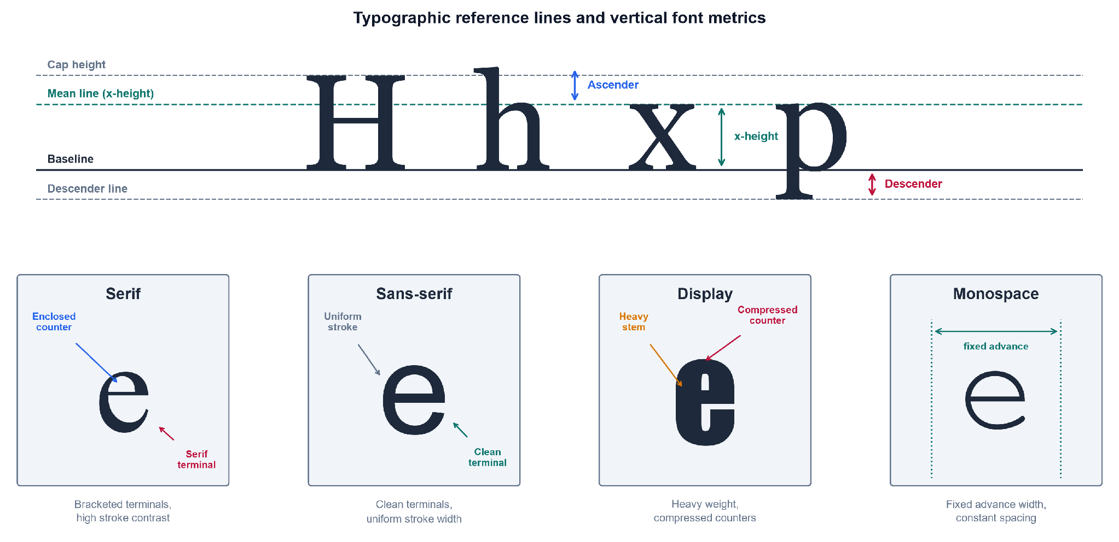
Font anatomy panel showing x-height, terminal, stroke contrast, and counter across serif, sans-serif, display, and monospace families
As shown in Figure 1, font identity is carried by fine-grained geometric traits rather than by the identity of the character itself, which is why this thesis reasons over visual texture instead of textual meaning.

3.2.2 Convolutional Neural Networks and Visual Feature Extraction
The dominant deep-learning tool for reading such visual traits is the convolutional neural network (CNN), an architecture that exploits the spatial structure of images through local, weight-sharing operations (LeCun, Bengio, & Hinton, 2015). Its central operation is convolution, in which a small kernel (also called a filter, a compact matrix of learnable weights) is slid across the image, computing a weighted sum at every position:
$(I*K)(i,j)=\sum_{m}{}\sum_{n}{}I(i+m, j+n) K(m,n)$
Here $I$ is the input image (a two-dimensional array of pixel intensities), $K$ is the kernel, $(i,j)$ is the output spatial location, and $m,n$ index positions within the kernel. The resulting array is a feature map, an image in which each value records how strongly the kernel’s pattern (an edge, a corner, a serif) is present at that location. The region of the input that influences a single feature-map value is that value’s receptive field; stacking convolutional layers enlarges the receptive field, so deeper layers respond to progressively larger and more abstract structures (Goodfellow, Bengio, & Courville, 2016). The spatial size $O$ of a feature map is determined by the input and kernel geometry:
$O=⌊\frac{W−F+2P}{S}⌋+1$
where $W$ is the input width (in pixels), $F$ is the kernel size, $P$ is the amount of zero-padding added to the border, $S$ is the stride (the step size between kernel positions), and $⌊⋅⌋$ denotes the floor function. Between convolutional layers, pooling downsamples each feature map, usually by taking the maximum value in each small window, which shrinks the representation and grants tolerance to small shifts in glyph position (Sarker, 2021). Figure 2 presents this convolution-pooling-classification pipeline.
Figure 2
Simplified Architecture of a Convolutional Neural Network
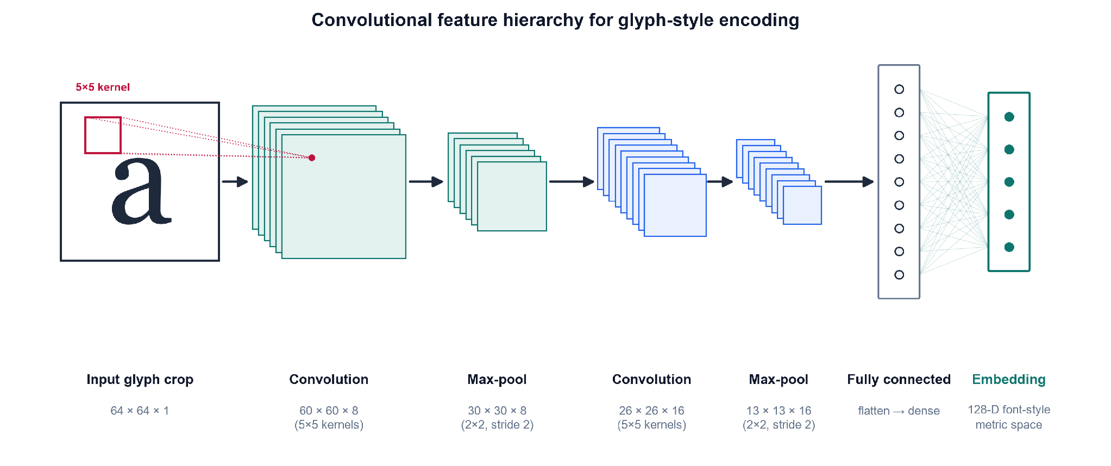
Block diagram of a CNN showing successive convolution and pooling layers feeding a fully connected classification block
Note. Adapted from LeCun, Bengio, and Hinton (2015) and Goodfellow, Bengio, and Courville (2016).
As shown in Figure 2, a CNN processes an image through successive convolution and pooling stages before a fully connected block. This staged processing produces the hierarchical feature learning on which later chapters depend.

3.2.3 Typographic Hallucination
The input distribution this thesis targets is not clean type but typographic hallucination: the probabilistic glyph deformation introduced when generative AI image models render text, including micro-warping, elastic distortion, and variable kerning (inconsistent spacing between characters). Kondo et al. (2024) demonstrate that diffusion models natively emit novel, unclassified glyph geometries when interpolating in latent space. This establishes that the deformations are an intrinsic output of the model class rather than an occasional artifact. To make this precise, hallucination is modeled here as a degradation operator $D$ applied to a pristine glyph crop:
$\tilde{x}=D\left(x; θ_{warp}, θ_{blur}, θ_{kern}\right)$
where $x$ is the clean rendered crop, $\tilde{x}$ is the resulting hallucinated crop, and $D$ composes three parameterized corruptions: an elastic warp (governed by $θ_{warp}$), Gaussian blur and noise ($θ_{blur}$), and kerning jitter ($θ_{kern}$). This operator, illustrated in Figure 3, is the formal object the synthetic-data pipeline of Chapter 4 will instantiate to train a deformation-robust recognizer. Modeling degradation as controlled, layered augmentation follows established practice: Plastropoulos and Tegos (2024) show that combining such transformations with deep feature extraction forces networks to learn resilient, continuous shape boundaries.

Figure 3
The Typographic-Hallucination Degradation Pipeline
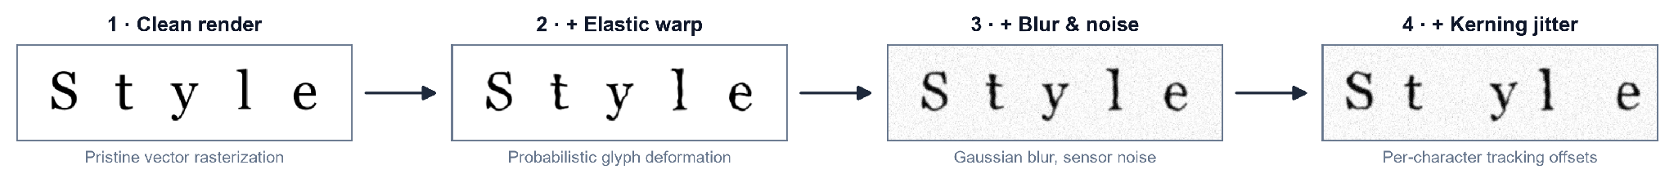
Degradation pipeline transforming a clean glyph through elastic warp, then Gaussian blur and noise, then kerning jitter
As shown in Figure 3, each stage of $D$ moves the glyph further from its pristine form and reproduces the exact deformations that cause commercial font identifiers to fail.

3.2.4 Embedding Spaces
Rather than emit a single hard label, the framework maps each crop into an embedding: a fixed-length vector of real numbers, produced by a deep network, that summarizes the visual content of the input. The set of all such vectors forms an embedding space, a continuous geometric space in which proximity encodes similarity, so that crops set in the same typeface should land close together and crops from different typefaces far apart (LeCun, Bengio, & Hinton, 2015). Representing fonts as points in a continuous space, rather than as entries in a fixed list, is what allows a hallucinated crop to be placed near its source typeface even when it matches none exactly. This is the property that the next section’s theoretical foundations formalize.

3.3 Theoretical Foundations
Having defined the visual objects and the network that reads them, this section develops the mathematics that turns embeddings into decisions. It moves from the general question of how a model can be trained at all to the two specific mechanisms this thesis assembles: metric learning, which shapes the embedding space so that distance means typographic similarity, and open-set recognition, which lets the system refuse to answer when a crop belongs to no known font.

3.3.1 Learning Paradigms
A deep network is trained by minimizing a loss function, a scalar-valued function that measures the gap between the model’s output and the desired output; optimization adjusts the network’s weights to make this quantity small. How the desired output is supplied defines the learning paradigm. In supervised learning, every training image carries a label (a human-assigned ground-truth answer, such as the font name), and the loss penalizes disagreement between prediction and label (Sarker, 2021). In unsupervised learning no labels exist, and the model must discover structure, such as clusters or densities, from the raw inputs alone. Self-supervised learning occupies the middle ground: it manufactures a supervisory signal from the data itself, for instance by asking the network to make two augmented views of one image agree, and so gains the benefits of supervision without manual annotation. This distinction matters here because in-the-wild generative-AI crops arrive without font labels, which pushes the thesis toward metric and self-supervised formulations rather than a purely supervised classifier.

3.3.2 Metric Learning and Embedding Distance
Metric learning is the family of methods that trains an embedding function $f_{θ}$ (a network, with parameters $θ$, that maps an input crop to a vector) so that geometric distance in the output space corresponds to semantic similarity (Schroff, Kalenichenko, & Philbin, 2015). Two distances are used to compare embeddings. The Euclidean distance between two crops $a$ and $b$ is
$d(a,b)={‖f(a)−f(b)‖}_{2},$
where $f(a)$ and $f(b)$ are their embedding vectors and ${‖⋅‖}_{2}$ is the $L^{2}$ (straight-line) norm; smaller $d$ means greater similarity. Cosine similarity instead measures the angle between the two vectors,
$cos(a,b)=\frac{f(a)⋅f(b)}{‖f(a)‖ ‖f(b)‖},$
where $f(a)⋅f(b)$ is the dot product; it ranges from $−1$ to $1$ and ignores vector magnitude, so it captures only direction.
To force these distances to encode font identity, the embedding is trained with a triplet loss. A triplet consists of an anchor crop $a$, a positive $p$ set in the same typeface as the anchor, and a negative $n$ set in a different typeface. The loss is
$L=\sum_{i}{}{\left[ {‖f(a_{i})−f(p_{i})‖}^{2}−{‖f(a_{i})−f(n_{i})‖}^{2}+α \right]}_{+},$
where the sum runs over triplets, $α$ is the margin (a minimum required gap between the anchor-positive and anchor-negative distances), and $[ ⋅ ]_{+}=max(0,⋅)$ keeps only positive violations (Schroff et al., 2015). Minimizing $L$ pulls same-font crops together and pushes different-font crops apart by at least $α$. FaceNet established this on face identity, but it was validated only on clean, photographic faces, not on deformed glyphs. Two further results extend the rationale to the regime here. Huang and Zhou (2022) show that deep networks can decompose complex visual domains into structured feature vectors that support continuous proximity rankings rather than hard label buckets, and Umer et al. (2022) provide the optimization backing for tracking structural closeness on high-variance, distorted geometries. A cleaner space still helps: Wang et al. (2024) impose a non-negativity constraint on contrastive features, which yields sparse, axis-aligned embeddings, though their guarantees are also demonstrated on standard benchmarks rather than on typographic deformation.

3.3.3 Open-Set Recognition and Rejection Scores
A metric embedding still assumes every query belongs to some trained class. Open-set recognition removes that assumption: it partitions inputs into known classes (fonts seen in training) and the unknown class (anything else), and must reject the unknown instead of forcing it into a known bucket. The formal hazard is open-space risk $R_{O}(f)$, which is roughly the fraction of the large “open space” far from any training example that a recognizer nonetheless labels as a known font. Because a bounded amount of training data cannot fence off an unbounded space, minimizing $R_{O}(f)$ requires a rejection score (a scalar that summarizes how confidently an input belongs to any known class), compared against a threshold below which the input is declared unknown (Lu et al., 2025). Figure 4 depicts this geometry.
Figure 4
Embedding Space with Known-Font Clusters and an Open-Set Rejection Boundary
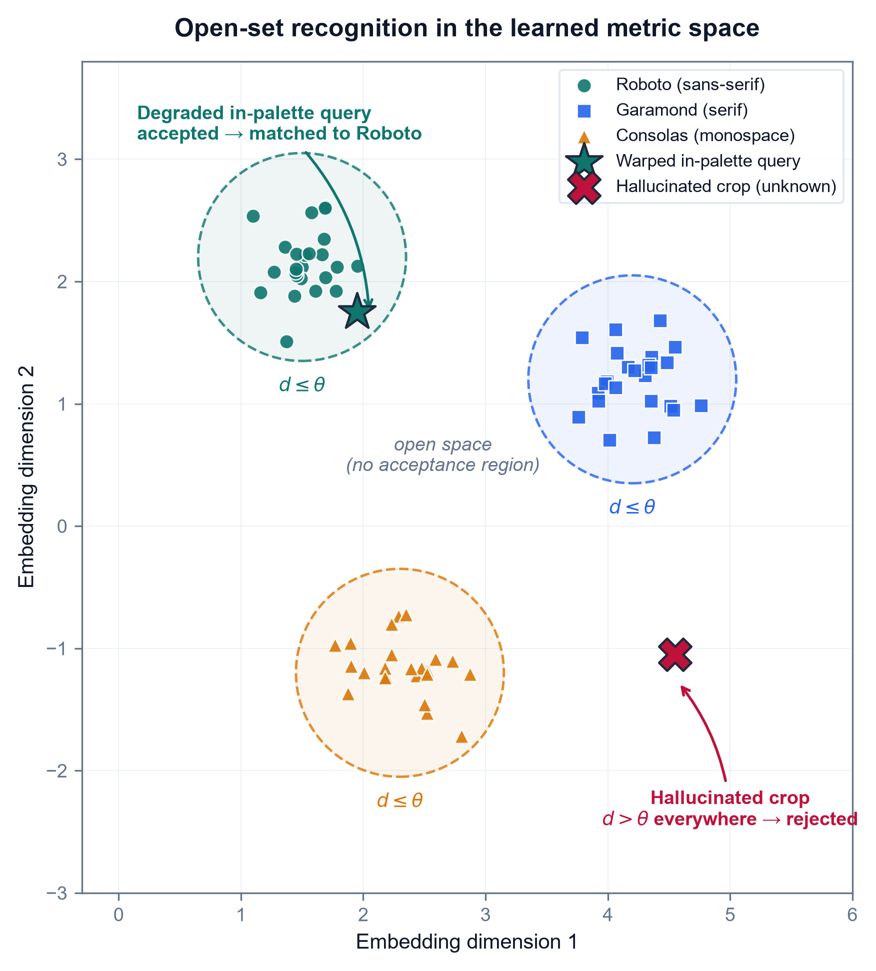
Two-dimensional embedding scatter showing compact known-font clusters enclosed by a rejection boundary, with a hallucinated out-of-palette crop falling outside all clusters
As shown in Figure 4, known typefaces form compact clusters while a hallucinated, out-of-palette crop lands in the open region beyond the rejection boundary, which is the case a threshold on the rejection score is meant to catch.
The rejection score can be read at several points in the network. Many scores start from the logits (the raw, pre-normalization outputs $f_{i}(x)$ of the classification layer for each class $i$), which the softmax function converts to a probability distribution,
$σ(z)_{i}=\frac{e^{z_{i}}}{\sum_{j}{}e^{z_{j}}},$
where $z_{i}$ is the logit for class $i$ and the denominator sums over all classes so the outputs total one. Softmax confidence alone is a poor rejection score because networks are overconfident off-manifold; the recent literature therefore reads richer signals. Hofmann et al. (2024) compute an energy score,
$E(x)=−T⋅log\sum_{i}{}exp​\left(f_{i}(x)/T\right),$
where $T$ is a temperature constant and the sum runs over class logits; low energy indicates an in-distribution input and high energy flags the unknown, and they sharpen the boundary by mining hard outliers near it. Djurisic et al. (2024) keep the decision in logit space but rescale the whole logit vector by a feature-derived scalar before thresholding, and this requires no retraining. Karunanayake et al. (2025) argue that the ranking of the runner-up classes is itself diagnostic, and far more deterministic for known inputs than for unknown ones. This idea maps directly onto a Top-K font shortlist, where the order of the second- and third-place fonts signals a hallucinated glyph. The limitation that ties all four together is that every one of these scores is validated on natural-image out-of-distribution benchmarks (CIFAR, ImageNet). None has been tested on typographic out-of-distribution input, the probabilistic warping and variable kerning this thesis targets. Whether these scores transfer to font hallucination over a localized palette is the question the methodology sets out to answer.

3.4 Existing Technologies & Frameworks
The theory of the previous section is realized through concrete software tools and neural architectures. This section surveys the ones the methodology builds on. Because every framework should be judged on both sides, each is paired with what it does well and where it falls short on this thesis's deformed-glyph regime. The tools divide into a representation stack (a library, a backbone architecture, a frozen encoder, and a parameter-efficient adaptation method) and a measurement stack (structural-similarity metrics), followed by the generative process that produces the input distribution in the first place.

3.4.1 PyTorch and the Vision Transformer Backbone
A deep-learning framework is a software library that supplies the building blocks (tensor operations, automatic differentiation, and pre-built layers) for defining and training networks. PyTorch is the framework adopted here; its central strength is a dynamic computation graph, which means the network structure is defined on the fly as code executes, together with autograd, which automatically computes the gradients that optimization needs. This flexibility makes PyTorch well suited to research prototyping, but it is deliberately domain-agnostic: it provides no built-in typographic priors, so all font-specific structure must be supplied by the model and data the researcher constructs.
The backbone architecture is the Vision Transformer (ViT), which processes an image not through convolution but by splitting it into a grid of fixed-size patches, flattening each patch into a patch embedding (a vector), and letting the patches interact through self-attention. Self-attention, introduced by Vaswani et al. (2017), lets every element of a sequence weigh the relevance of every other element. Each patch embedding is projected into three vectors, a query $Q$, a key $K$, and a value $V$, and the operation is
$Attention(Q,K,V)=softmax​\left(\frac{QK^{⊤}}{\sqrt{d_{k}}}\right)V,$
where $QK^{⊤}$ scores how well each query matches each key, $d_{k}$ is the key dimension whose square root rescales the scores to keep them numerically stable, softmax turns the scores into weights summing to one, and $V$ carries the aggregated content. Figure 5 depicts this patch-embedding-and-attention flow.
Figure 5
Vision Transformer Patch Embedding and Self-Attention
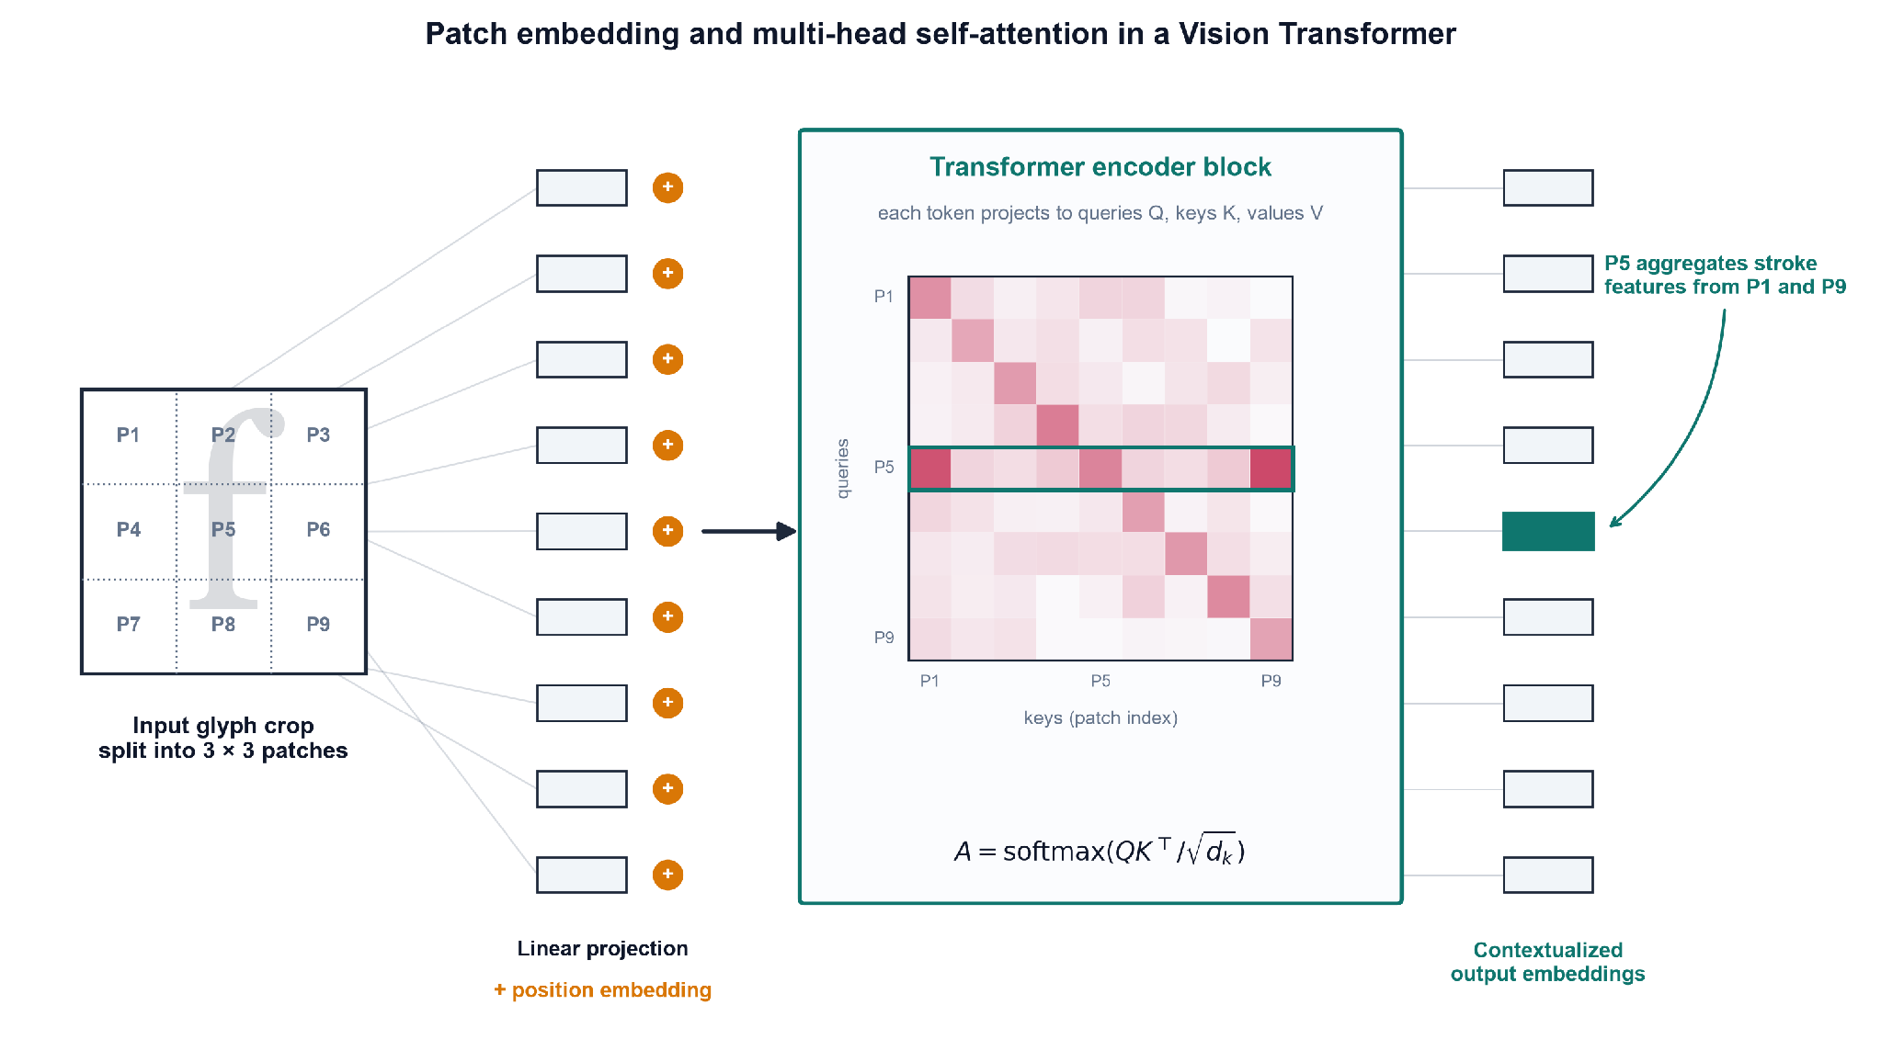
Schematic of an image split into patches, each linearly embedded and passed through multi-head self-attention that links distant patches
Note. Adapted from Vaswani et al. (2017) and Wang, Lv, et al. (2025).
As shown in Figure 5, self-attention links spatially distant patches directly, which is why Wang, Lv, et al. (2025) use a ViT to parse long-range document layout that fixed convolutional receptive fields cannot span. The limitation is twofold: self-attention is data-hungry and needs large training sets to generalize, and its all-pairs comparison has quadratic cost in the number of patches, which makes high-resolution inputs expensive.

3.4.2 Self-Supervised Frozen Encoders
Training a ViT from scratch is the data-hungry step this thesis wants to avoid. DINOv2 (Oquab et al., 2024) is a ViT trained by self-supervised distillation to produce all-purpose visual features that transfer to fine-grained classification and retrieval with no fine-tuning. Used as a frozen encoder, with its weights held fixed while only downstream components are trained, it lets the framework read patch-level embeddings from a glyph crop without building a font-specific network from scratch, and Sheikh et al. (2024) show the same frozen-DINO family extract layout structure with no labels at all. Its weakness is that these features are not clean: Darcet et al. (2024) identify high-norm artifact tokens that self-supervised ViTs repurpose for internal computation in low-information image regions, which corrupts the feature map. Their fix is register tokens (extra dedicated tokens that absorb this internal computation), which restore smooth attention and feature maps. That repair matters directly for glyph crops, whose informative signal is a few thin strokes on empty ground; yet, like the backbone itself, registers are validated only on natural images, never on re-rendered type.

3.4.3 Parameter-Efficient Fine-Tuning
A frozen encoder trades adaptation for economy: its weights never move, so it cannot specialize to type. Full fine-tuning restores that specialization but at prohibitive cost, updating all of the backbone’s parameters (87.2 million for a ViT-B/14) and storing a full copy per task. Parameter-efficient fine-tuning (PEFT) is the middle path, adapting a large pre-trained model to a new task by training only a small set of new parameters while the original weights stay frozen. The dominant PEFT method is Low-Rank Adaptation (LoRA), which rests on the observation that the update a model needs for a new task has low intrinsic rank. Rather than learn a full weight-update matrix $ΔW$ for a layer, LoRA factors it into two thin matrices:
$W^{′}=W_{0}+ΔW=W_{0}+\frac{α}{r} BA,$
where $W_{0}$ is the frozen pre-trained weight matrix, $A$ and $B$ are the trainable low-rank factors (with $A∈R^{r×k}$, $B∈R^{d×r}$), $r$ is the rank (a small integer, e.g. $r=8$, that bounds how much the update can express), and $α$ is a scaling factor that controls the update’s magnitude. Because $r$ is far smaller than the layer’s dimensions, the product $BA$ reconstructs a full-size update from a tiny number of parameters. Chen et al. (2026) adapt a frozen DINOv2 ViT-B/14 to font classification this way with $r=8$ and $α=16$, training roughly 150,000 parameters — about 0.2% of the backbone — and reach approximately 86% Top-1 accuracy across 394 Google Font variants, with the trained factors mergeable back into $W_{0}$ so inference incurs no added cost. The strength is decisive economy: the frozen backbone preserves its general visual knowledge while a negligible adapter specializes it, avoiding both the compute of full fine-tuning and the label-free ceiling of a purely frozen encoder. The limitations are equally direct and shape this thesis’s design. LoRA adaptation is supervised and closed-set — Chen et al. train on labeled synthetic renders over a fixed 394-class catalogue — and their model, trained exclusively on pristine synthetic type, is self-reported to fail on photographs and heavily styled graphics; its residual errors concentrate between near-identical weight variants of the same family (family-level accuracy falls to 40.2%), which the authors attribute to detail lost at the 224×224 input resolution. PEFT thus offers a cheap route to a specialized typographic encoder, but one whose closed-set, clean-glyph training is the very regime this thesis’s open-set, deformation-robust framing is built to move beyond.

3.4.4 Structural-Similarity Metrics
To score how well a predicted font matches a crop, the framework needs a structural-similarity metric, a measure of perceptual, structural agreement rather than pixel-by-pixel identity. The original one is the Structural Similarity Index (SSIM) of Wang et al. (2004), which models similarity as a product of luminance, contrast, and structure terms:
$SSIM(x,y)=\frac{(2μ_{x}μ_{y}+C_{1})(2σ_{xy}+C_{2})}{(μ_{x}^{2}+μ_{y}^{2}+C_{1})(σ_{x}^{2}+σ_{y}^{2}+C_{2})},$
where $μ_{x},μ_{y}$ are the mean intensities of the two image windows $x$ and $y$, $σ_{x}^{2},σ_{y}^{2}$ their variances, $σ_{xy}$ their covariance, and $C_{1},C_{2}$ small constants that prevent division by zero. SSIM is interpretable and computationally light, but classical pixel-SSIM collapses under geometric misalignment (when the two images are warped or shifted relative to each other), which is the normal case for a hallucinated glyph. Figure 6 illustrates the re-render-and-compare protocol this metric serves.
Figure 6
Structural-Similarity Re-Render-and-Compare Pipeline
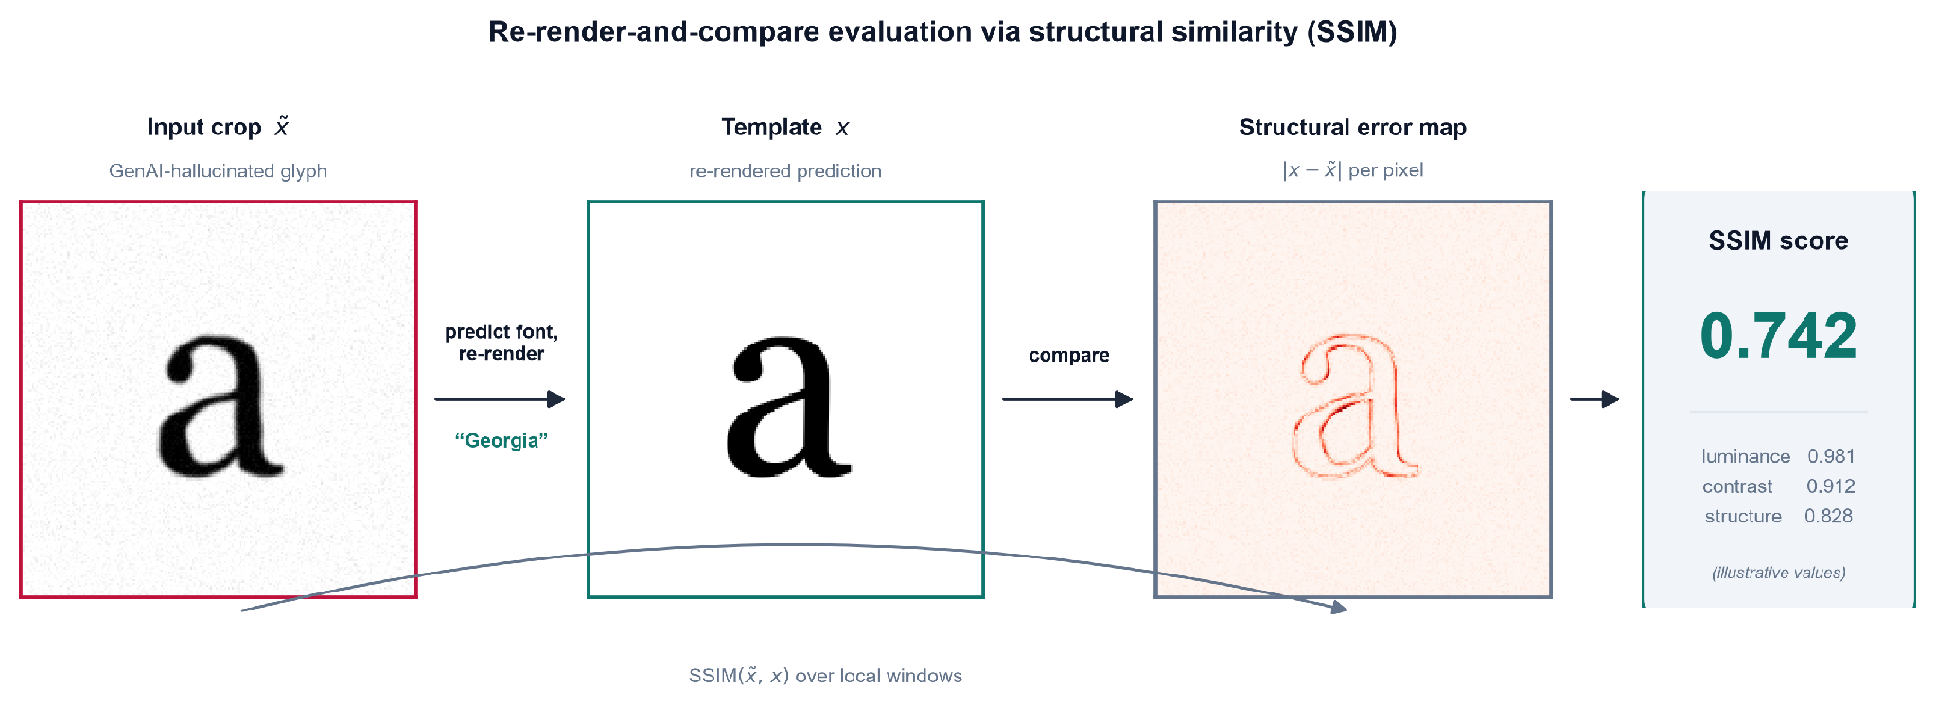
Pipeline rendering a predicted font to a clean glyph, then scoring its structural similarity against the deformed input crop
As shown in Figure 6, the predicted typeface is re-rendered and scored against the input crop, which is where classical SSIM’s alignment assumption breaks. Two deep successors address this: Zhang et al. (2024) compute DeepSSIM over deep feature maps with an attention-calibration step, which keeps the score valid under geometric misalignment, and Li et al. (2025) build SAMScore on segmentation-model embeddings to measure whether a transformed image preserves source content structure. Both are deformation-robust in principle, but both were validated on natural-image translation tasks, never on re-rendered glyphs. That untested transfer is what this thesis must confront.

3.4.5 Latent Diffusion as the Generative Source
Finally, the input distribution itself originates from latent diffusion, the class of generative models that synthesize images by iteratively denoising a compressed latent representation. Kondo et al. (2024) show that interpolating in this latent space natively emits novel, unclassified glyph geometries with fluid visual traits, which is peer-reviewed evidence that typographic deformation is intrinsic to the model class. Its strength as a generator is its weakness for this thesis: the process is uncontrolled with respect to font identity and produces glyphs that belong to no catalogued typeface. Diffusion is therefore the source of the problem this framework must handle, not a solution to it. That is why the thesis treats its deformed output as the input distribution, which the following chapter’s pipeline is built to handle.

3.5 Problem Context
Having assembled the concepts, theory, and tooling, this section states why no existing solution suffices on the input distribution this thesis targets: the in-the-wild GenAI crop, a fragment of text lifted from a generative-AI image whose glyphs are probabilistically deformed rather than pristine. Each mature tool works well on the distribution it was built for and fails on this one.
Classical OCR and closed-boundary layout analysis are the first casualty. Ponnuru et al. (2024) digitize smudged, handwritten prescriptions at a 98% accuracy baseline, which shows that traditional pipelines handle environmental noise on anatomically correct text with ease; but their adaptive-thresholding and bounding-box machinery presupposes rigid glyph geometry, which the topological warping of hallucinated type dissolves. The DeepFont-style font-classify baseline established in Section 3.2 fails for a different reason: trained on clean synthetic glyphs, it is pristine over-fit (tuned so tightly to geometrically exact vectors that deformed input falls off its learned manifold) and closed-set (it assumes every query belongs to a catalogued class and is therefore forced to return some known font even when the true typeface is absent). The measurement tools inherit the same brittleness: classical pixel-SSIM (Section 3.4) demands pixel registration, an exact per-pixel correspondence between the two images, which warped, re-kerned glyphs break outright. A general vision-language model is no escape either; Li, Song, et al. (2025) show that state-of-the-art VLMs get lost in font recognition, derailed by the word’s semantic content instead of reading its visual texture. Even the closest typographic precedent falls short: the L2@k and cos@k font-fidelity metrics of Jiang et al. (2025), computed over the very Storia-AI classifier this thesis adopts as its baseline, assume an undeformed input glyph and so cannot faithfully score a hallucinated crop. That the deformation is endemic rather than incidental is settled by Liu et al. (2024), who find that an uncorrected generative pipeline renders text correctly less than 20% of the time, which is the empirical size of the problem this thesis exploits.
These failures converge on a single consolidated gap. No existing framework couples an attention-isolated text crop → a deformation-robust, frozen-ViT metric embedding → open-set font-identity ranking with a calibrated Top-K over a localized open-set palette (the top 50 to 100 Google Fonts) on the GenAI-deformed input distribution. Figure 7 previews the end-to-end framework this thesis assembles to fill that gap.

Figure 7
End-to-End Architecture of the Proposed Font-Style Recognition Framework
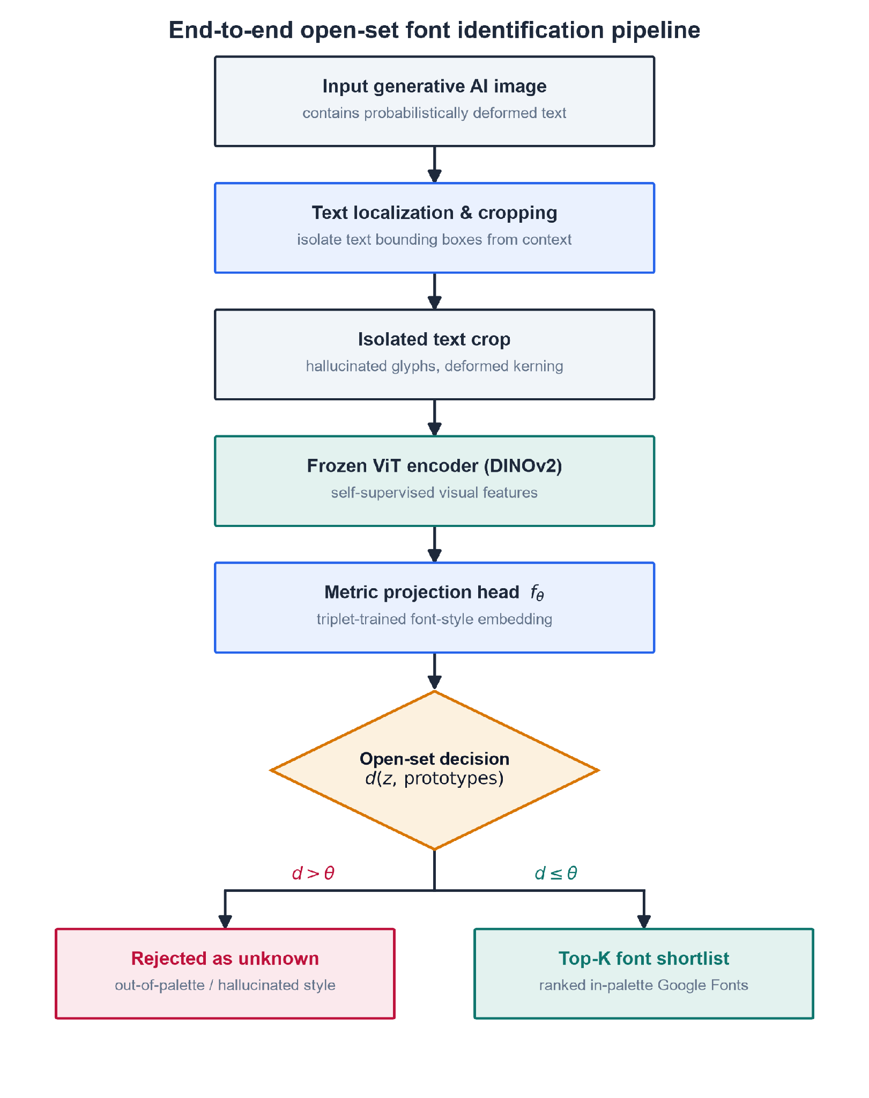
Flowchart of the proposed pipeline: a GenAI image feeds attention-based crop isolation, then a frozen Vision Transformer encoder, then a metric-embedding head, then open-set ranking with a calibrated Top-K shortlist over the localized Google-Fonts palette
As shown in Figure 7, an isolated crop flows through the frozen-ViT encoder into a metric embedding, where an open-set rejection score and a calibrated Top-K produce a ranked shortlist over the localized Google-Fonts palette. This is the coupling that the preceding tools, taken one at a time, leave unbuilt.
Having established the typographic, deep-learning, metric-learning, and open-set foundations, along with the specific technical gap they leave open, the next chapter details the synthetic-degradation pipeline that manufactures deformed training data, the model architecture that embeds and ranks each crop, and the evaluation protocol that measures the framework against a human-proxy baseline.

Bibliography

Bibliography

Bhunia, A. K., Bhunia, A. K., Banerjee, P., Konwer, A., Bhowmick, A., Roy, P. P., & Pal, U. (2018). Document processing and geometric boundary layouts. In 2018 24th International Conference on Pattern Recognition (ICPR). IEEE. https://ieeexplore.ieee.org/abstract/document/8545184

Chowdhury, A., Mehrab, K. S., Campolongo, E. G., Rubenstein, D., Stewart, C. V., Karpatne, A., Berger-Wolf, T., Su, Y., & Chao, W.-L. (2025). Prompt-CAM: Making vision transformers interpretable for fine-grained analysis. In Proceedings of the IEEE/CVF Conference on Computer Vision and Pattern Recognition (CVPR). https://arxiv.org/abs/2501.09333

Darcet, T., Oquab, M., Mairal, J., & Bojanowski, P. (2024). Vision transformers need registers. In International Conference on Learning Representations (ICLR). https://arxiv.org/abs/2309.16588

Ding, T., Fermanian, J.-B., & Salmon, J. (2025). Conformal prediction for long-tailed classification. arXiv. https://arxiv.org/abs/2507.06867

Djurisic, A., Liu, R., & Nikolic, M. (2024). Logit scaling for out-of-distribution detection. arXiv. https://arxiv.org/abs/2409.01175

Du, N., Xie, R., Chen, Z., Wang, Q., Jiang, Z., Zhang, K., Yang, J., & Tai, Y. (2025). TextCrafter: Investigating text insulation and attention mechanisms for complex visual text generation. arXiv. https://arxiv.org/abs/2503.23461

Gillani, S. A., Baig, M. S. A., Khan, O. A., Shah, S. M., Mujeeb, U., & Ali, M. (2025). TextPixs: Glyph-conditioned diffusion with character-aware attention and OCR-guided supervision. arXiv. https://arxiv.org/abs/2507.06033

Goodfellow, I., Bengio, Y., & Courville, A. (2016). Deep learning. MIT Press. https://www.deeplearningbook.org/

Hofmann, C., Schmid, S., Lehner, B., Klotz, D., & Hochreiter, S. (2024). Energy-based Hopfield boosting for out-of-distribution detection. In Advances in Neural Information Processing Systems (Vol. 37). https://proceedings.neurips.cc/paper_files/paper/2024/hash/ee20461718669c6c9c5da478d46d60d9-Abstract-Conference.html

Huang, Z., & Zhou, J. (2022). Specialized deep metric and feature topology. Neurocomputing. https://www.sciencedirect.com/science/article/pii/S0925231221013886

Jiang, B., Yuan, Y., Bai, X., Hao, Z., Yin, A., Hu, Y., Liao, W., Ungar, L., & Taylor, C. J. (2025). ControlText: Unlocking controllable fonts in multilingual text rendering without font annotations. In Findings of the Association for Computational Linguistics: EMNLP 2025. https://arxiv.org/abs/2502.10999

Karunanayake, N., Seneviratne, S., & Chawla, S. (2025). ExCeL: Combined extreme and collective logit information for enhancing out-of-distribution detection. Transactions on Machine Learning Research. https://arxiv.org/abs/2311.14754

Kondo, T., Takezaki, S., Haraguchi, D., & Uchida, S. (2024). Font style interpolation with diffusion models. In Document Analysis and Recognition – ICDAR 2024. Springer. https://doi.org/10.1007/978-3-031-70536-6_6

LeCun, Y., Bengio, Y., & Hinton, G. (2015). Deep learning. Nature, 521(7553), 436–444. https://doi.org/10.1038/nature14539

Li, Y., Chen, M., Wang, K., Ma, J., Bovik, A. C., & Zhang, Y. (2025). SAMScore: A content structural similarity metric for image translation evaluation. arXiv. https://arxiv.org/abs/2305.15367

Li, Z., Li, X., Fu, X., Zhang, X., Wang, W., Chen, S., & Yang, J. (2024). PromptKD: Unsupervised prompt distillation for vision-language models. In Proceedings of the IEEE/CVF Conference on Computer Vision and Pattern Recognition (CVPR). https://arxiv.org/abs/2403.02781

Li, Z., Song, G., Cai, Y., Xiong, Z., Yuan, J., & Wang, Y. (2025). Texture or semantics? Vision-language models get lost in font recognition. arXiv. https://arxiv.org/abs/2503.23768

Liu, Z., Liang, W., Liang, Z., Luo, C., Li, J., Huang, G., & Yuan, Y. (2024). Glyph-ByT5: A customized text encoder for accurate visual text rendering. arXiv. https://arxiv.org/abs/2403.09622

Lu, S., Wang, Y., Sheng, L., He, L., Zheng, A., & Liang, J. (2025). Out-of-distribution detection: A task-oriented survey of recent advances. ACM Computing Surveys. https://doi.org/10.48550/arXiv.2409.11884

Oquab, M., Darcet, T., Moutakanni, T., Vo, H., Szafraniec, M., Khalidov, V., Fernandez, P., Haziza, D., Massa, F., El-Nouby, A., Assran, M., Ballas, N., Galuba, W., Howes, R., Huang, P.-Y., Li, S.-W., Misra, I., Rabbat, M., Sharma, V., … Bojanowski, P. (2024). DINOv2: Learning robust visual features without supervision. Transactions on Machine Learning Research. https://arxiv.org/abs/2304.07193

Plastropoulos, A., & Tegos, K. (2024). A review of machine learning and deep learning for object detection, semantic segmentation, and human action recognition in machine and robotic vision. Technologies, 12(2), 15. https://doi.org/10.3390/technologies12020015

Ponnuru, M., Sridevi Ponmalar, P., Likhitha, A., Tanu Sree, B., & Guna Chaitanya, G. (2024). OCR for prescription data extraction. Procedia Computer Science. https://www.sciencedirect.com/science/article/pii/S1877050924007786

Sarker, I. H. (2021). Deep learning: A comprehensive overview on techniques, taxonomy, applications and research directions. SN Computer Science, 2, 420. https://doi.org/10.1007/s42979-021-00815-1

Schroff, F., Kalenichenko, D., & Philbin, J. (2015). FaceNet: A unified embedding for face recognition and clustering. In Proceedings of the IEEE Conference on Computer Vision and Pattern Recognition (CVPR) (pp. 815–823). https://doi.org/10.1109/CVPR.2015.7298682

Sheikh, T. U., Shehzadi, T., Hashmi, K. A., Stricker, D., & Afzal, M. Z. (2024). UnSupDLA: Towards unsupervised document layout analysis. In Document Analysis and Recognition – ICDAR 2024 Workshops. Springer. https://doi.org/10.1007/978-3-031-70546-5_2

Shi, Y., Ghosh, S., Belkhouja, T., Doppa, J. R., & Yan, Y. (2024). Conformal prediction for class-wise coverage via augmented label rank calibration. arXiv. https://arxiv.org/abs/2406.06818

Shu, Y., Zeng, W., Zhao, F., Chen, Z., Li, Z., Yang, X., Zhou, Y., Rota, P., Bai, X., Jin, L., Yin, X.-C., & Sebe, N. (2025). Visual text processing: A comprehensive review and unified evaluation. arXiv. https://arxiv.org/abs/2504.21682

Umer, S., Mondal, R., Pandey, H. M., & Rout, R. K. (2022). Soft computing frameworks for visual alignment. Applied Soft Computing. https://www.sciencedirect.com/science/article/pii/S1568494621008395

Vaswani, A., Shazeer, N., Parmar, N., Uszkoreit, J., Jones, L., Gomez, A. N., Kaiser, Ł., & Polosukhin, I. (2017). Attention is all you need. In Advances in Neural Information Processing Systems (Vol. 30). https://proceedings.neurips.cc/paper/2017/hash/3f5ee243547dee91fbd053c1c4a845aa-Abstract.html

Wang, Y., Lv, W., Wu, W., Xie, G., Lu, B., Wang, C., Zhan, C., & Su, B. (2025). TransTab: A transformer-based approach for table detection and tabular data extraction from scanned document images. Machine Learning with Applications. https://www.sciencedirect.com/science/article/pii/S2666827025000489

Wang, Y., Zhang, Q., Guo, Y., & Wang, Y. (2024). Non-negative contrastive learning. In International Conference on Learning Representations (ICLR). https://arxiv.org/abs/2403.12459

Wang, Z., Bovik, A. C., Sheikh, H. R., & Simoncelli, E. P. (2004). Image quality assessment: From error visibility to structural similarity. IEEE Transactions on Image Processing, 13(4), 600–612. https://doi.org/10.1109/TIP.2003.819861

Wang, Z., Yang, J., Jin, H., Shechtman, E., Agarwala, A., Brandt, J., & Huang, T. S. (2015). DeepFont: Identify your font from an image. In Proceedings of the 23rd ACM International Conference on Multimedia (pp. 451–459). https://doi.org/10.1145/2733373.2806219

Zhang, K., Chen, W., Zhao, T., & Wang, Z. (2024). Structural similarity in deep features: Image quality assessment robust to geometrically disparate reference. arXiv. https://arxiv.org/abs/2412.19553

Zhuang, S., Huang, M., Fu, F., Chen, N., Lei, B., & Mao, Z. (2025). HDGlyph: A hierarchical disentangled glyph-based framework for long-tail text rendering in diffusion models. arXiv. https://arxiv.org/abs/2505.06543

Combined

Chapter 2: Review of Related Literature

2.1 Introduction
This chapter reviews the literature defining the scope of this thesis and introduces the components of the proposed solution. The review is organized around the structure of the problem itself. It first establishes the limits of current approaches, describes the phenomenon that undermines them, and then introduces the components needed to resolve these limitations. Five thematic areas race this progression. Legacy font recognition, OCR/Layout and Closed-Set Vector assumptions reviews visual font recognition, the paradigm this work challenges. Traditional methods including DeepFont, classical OCR, Layout analysis, and attention-based localization rely on a closed-set, rigid-glyph assumption. However, generative AI text violates this assumption. Generative AI typographic hallucinations and diffusion latent mutations details these violations, specifically the micro warping, variable kerning, and cross-character attention smearing that this thesis terms typographic hallucination. Existing generative AI research only studies these deformations to suppress them inside the generator, rather than to recover typeface identity from the deformed output. The next three themes build the proposed recognizer. Logit-space thresholds and open-set rejection scores describe the open-set rejection machinery that labels out of palette crops as “unknown”. Feature disentanglement and Frozen-ViT Metric Embedding details the disentangled frozen-ViT embedding used to calculate the rejection score. Advanced Visual Distance Metrics (SSIM) and Human-Proxy Ground-Truth Alignment introduces the deformation-robust distance metric and calibrated Top-K measurement layer used to validate the pipeline.

2.2 Legacy Font Recognition, OCR/Layout & Closed-Set Vector Assumptions
Visual font recognition as a discipline has been studied for a while now, with traces to Wang, Yang, Jein, Shechtman, Aseem and Huang’s (2015) DeepFont with Adobe Research. It was the first, large-scale deep convulational system for identifying typefaces from photographic inputs. DeepFont’s innovations were inseparable from the assumptions that were built into it. It trained on a synthetic set of clean typographic specimens generated directly from font files, guaranteeing that the discriminative features the network learned were uncontaminated by rendering artifacts like noise. It learned to read the typeface, relating to its stroke ratios, serif geometry, terminal curvature and ascender-to-x-height proportions. It was evaluated under the Top-1/Top-3 (TopK) accuracy protocol that remains the discipline’s standard. It proved that a network trained on clean glyphs, can generalize real photographic inputs with useful accuracy. However this assumption of clean glyphs means that every input is presumed to contain a glyph which exists at render time, and recognition is the recovery of that “fixed” identity from an environmental degradation channel, such as pictures or documents. We adopt the Top-K protocol from DeepFont because it is the established standard, in a system where there is no clean glyph to recover, because signal and noise co-emerge from the same generative process.

The same assumption asserts itself in contemporary OCR and layout systems such as by Ponnuru et al. (2024) report 98% accuracy for a Tesseract-based prescription digitization pipeline under scanning defects, and closed-boundary layout analysis grows stable for bounding regions from coherent glyph interiors (Bhunia et al., 2018). Both systems implicitly compute for the same function, that function is well-posed only when an existing, antecedent glyph exists. It is undefined in this sense where the glyph in the image is not a degraded copy of a vector mastery but the primary output of a system with no access entirely to the intended typeface’s geometry.

Recent shifts in document layout analysis that includes Wang, Lv, et al.’s (2025) TransTab and Sheikh et al.’s (2024) UnSupDLA, have begun replacing rigid geometric priors with attention-based, layout-independent feature extraction, establishing a direct precedent for the unsupervised, frozen-ViT architecture adoption. However, while these new attempts to relax spatial constraints during localization, they leave the morphological assumptions of font identity untouched.
Methodologically, we can draw the theoretical scaffolding from Sarker’s (2021) deep-learning taxonomy to justify a lightweight metric head over a frozen backbone, and Plastropoulos and Tegos’s (2024) framework to license synthetic data augmentation via geometric and typographic degradation. Yet, because the broader literature, stretching from DeepFont’s foundational closed-set baseline (Wang et al., 2015) to modern attention-driven models as mentioned above, presumes topologically faithful glyphs or treats distortion merely as an external noise channel. None of these studies actually address whether font identity can be recovered from a glyph whose structural deformation is not noise to be inverted, but an irreducible, probabilistic property of a generative latent model.

2.3 Generative AI Typographic Hallucinations & Diffusion Latent Mutations
AI producing morphologically unreliable text is established by several literature studies. Liu et al. (2024) diagnosed the visual text rendering in Stable Diffusion XL, traces the failure to an architectural limitation: the standard text encoder for AI treats a character sequence as a semantic unit and lacks the sub-character spatial awareness needed for typographically accurate output. This resulted in fewer than 20% of uncorrected SDXL renderings as accurate. The study also proposes their own Glyph-ByT5 correction, which fine-tunes the encoder on glyph-conditioned data, and raises the accuracy to 90%, confirming the failure is architectural rather than fundamental. The fact is that for an uncorrected baseline, deformation is the default output state.

Li, Song, et al. (2025) figured out that state-of-the-art vision-language models (VLMs) are readily derailed by an effect: The “Stroop-type” semantic inference, in which the lexical meaning of the rendered word overrides the model’s reading of the visual typeface. Because this effect operates even on clean, legible text, semantic distraction and glyph deformation are independently sufficient to defeat general-purpose recognition. We close off off-the-shelf VLMs as a solution and create a dedicated visual-texture pipeline architecturally isolated from this lexical content.

Generative text deformation arises within the generator's attention structure, where cross-character attention bleeding causes micro-warping, variable kerning, and glyph blending (Gillani et al., 2025), alongside multi-instance typographic entanglement (Du et al., 2025). Crucially, this degradation concentrates in the typographic long tail (display, script, and rare faces), forcing a recognizer to exercise caution exactly where a font’s clean profile would otherwise inspire confidence (Zhuang et al., 2025). Furthermore, because diffusion models map style onto a continuous latent manifold rather than discrete catalogs, generative text yields morphologically novel glyphs sampled between known typographies (Kondo et al., 2024). While existing evaluation frameworks like VTPBench quantify these errors (Shu et al., 2025), the broader literature studies deformation exclusively to suppress it within the generator using character-centric metrics (CER/WER). However, none of these studies treats this documented deformation distribution as an inevitable input distribution to evaluate whether the underlying typeface identity remains recoverable.

2.4 Logit-Space Thresholds & Open-Set Rejection Scores
To bridge the gap between closed-set limitations and irregular generative outputs, we must establish an inferential system required for open-set rejection; rejecting out-of-palette hallucinations to an “unknown” bin rather than forcing an inaccurate classification. There are two studies that highlight a post-hoc layer approach: Hofmann et al.’s (2024) Energy-based Hopfield Boosting (EHB) and Djurisic et al.’s (2024) Logic Scaling (LTS). Hofmann et al.’s (2024) approach utilizes an energy formalism to isolate manifold outliers, while Djurisic et al.’s (2024) introduces architecture-agnostic magnitude normalization, crucial for domains lacking explicit out-of-distribution (OOD) training data. While Lu et al.’s (2025) survey validates these training-agnostic approaches as the only viable choice against an infinite out-of-palette baseline, there is a clear gap. Existing benchmarks evaluate these approaches exclusively on natural-image datasets (e.g, ImageNet, CIFAR) featuring course, object-level semantic differences, leaving the effectiveness of these methods unproved when applied to the micro-irregularities of generative font deformation.

2.5 Feature Disentanglement & Frozen-ViT Metric Embedding
Providing robust input for the rejection mechanism is highly important. A study by Wang et al., (2024) describes a representation layer that produces disentangled, axis-aligned features, making typographic identity mathematically orthogonal to deformation artifacts. The architecture uses a frozen, register-corrected DINOv2 backbone (Oquab et al., 2024; Darcet et al., 2024) to extract fine-grained patch features, bypassing domain-specific fine-tuning. To prevent “Stroop-type” interference, the approach uses trait-localized prompts (Chowdhury et al., 2025) and label-free prompt distillation (Li, Li, et al., 2024) to direct attention to letterform anatomy. This establishes a continuous metric space (Huang & Zhou, 2022) where proximity ranking replaces categorical assignment letting the model distinguish genuine typographic variance from hallucinatory corruption. The methods above work on clean typographic or natural-image benchmarks, but we do not know if frozen attention maps can localize anatomical strokes under the severe warping, smearing, and character bleeding common in diffusion-generated glyphs.

2.6 Advanced Visual Distance Metrics (SSIM) & Human-Proxy Ground-Truth Alignment
Evaluating output quality against an empirical standard presents a measurement layer that pairs deformation-robust structural distance with dynamically calibrated confidence sets. Because pixel-level metrics collapse under spatial shifts in generative outputs, a system with DeepSSIM (Zhang et al., 2024) and SAMScore (Li, Chen, et al., 2025) in a re-render-and-compare loop is highly suggested. This loop evaluates typographic structure using embeddings from deep feature spaces and region topologies, a method supported by continuous structural distance optimization (Umer et al., 2022). To turn classifier probabilities into reliable uncertainty claims, this work uses Rank-Calibrated Class-Conditional Conformal Prediction (RC3P) (Shi et al., 2024) and its prevalence-adjusted long-tail extension (Ding et al., 2025) to generate input-dependent prediction sets with formal mathematical coverage guarantees. While ControlText (Jiang et al., 2025) validates distribution matching and establishes the Storia-AI classifier baseline, current methods fail in open-set generative environments. In order to resolve this limitation, we can test its metric-calibration framework against a ground truth built from an expert panel scoring in-the-wild generative crops. This establishes a unified verification protocol that has been missing from the natural-image, biological, and clean typographic literature.

2.7 Synthesis
Although these five areas of literature are mature, their capabilities remain fragmented and have not been combined into a single pipeline. Legacy methods localize layouts but assume topological font fidelity (Sheikh et al., 2024; Wang et al., 2025). Generative studies analyze the micro-warp deformations that violate this assumption, but they treat these distortions as bugs to suppress rather than distributions to read (Gillani et al., 2025; Kondo et al., 2024). Meanwhile, open-set research models rejection scores only for coarse, object-level shifts in natural images (Hofmann et al., 2024; Karunanayake et al., 2025). Representation models isolate fine-grained visual traits but avoid generative distortions (Chowdhury et al., 2025; Oquab et al., 2024). Finally, measurement benchmarks evaluate structural distances only on clean or general translation datasets (Jiang et al., 2025; Zhang et al., 2024). The main challenge lies in connecting these domains. To address this, this thesis integrates attention-based layout isolation with a deformation-robust, trait-localized embedding. This embedding is then scored using an open-set framework calibrated for typographic shifts, and validated against human consensus using a coupled visual distance and conformal prediction protocol. The proposed framework operates post hoc without generative-domain annotations over a bounded open-set palette, and forms the foundation of our approach.

Chapter 3: Technical Background

3.1 Introduction to the Domain
This chapter gives the reader the theoretical and technical foundation that the methodology assumes, and it moves from the general to the specific. It first places the work within its parent computational fields and defines the core visual objects it manipulates: glyph anatomy, the typographic-hallucination model, the convolutional network, and the embedding space (Sections 3.1 and 3.2). It then develops the mathematics that turns those objects into decisions. Metric learning shapes an embedding space so that distance means typographic similarity, and open-set recognition lets the system refuse to answer (Section 3.3). Section 3.4 surveys the software tools and neural architectures the framework is built on, weighing each for what it does well and where it falls short. Section 3.5 draws these threads together onto the specific technical gap that motivates the thesis and hands off to the methodology.
This research belongs to a nested set of computational fields, and it sits at the innermost layer. The outermost field is artificial intelligence (AI), the broad study of systems that perform tasks normally requiring human intelligence. Inside AI is machine learning (ML), the subfield concerned with algorithms that improve at a task by learning statistical patterns from data rather than following hand-written rules (Sarker, 2021). Inside ML is deep learning (DL), a family of methods that stack many layers of simple non-linear transformations so that the system learns its own hierarchical representation of the input, from raw pixels up to abstract concepts, without human-engineered features (LeCun, Bengio, & Hinton, 2015). When deep learning is applied to images, it becomes computer vision (CV), the discipline of extracting meaning from visual signals such as photographs, documents, and rendered text.
More narrowly, this thesis addresses a specialized CV task: visual font-style recognition, the problem of identifying which typeface a piece of rendered text was set in, using only the image of the text. The classical version of this task, established by DeepFont (Wang et al., 2015), treats it as image classification over a fixed catalogue of fonts rendered as clean, geometrically exact glyphs. The regime this thesis targets is harder: text crops produced by generative AI image tools, in which the glyphs are probabilistically deformed rather than pristine. General-purpose vision-language models do not solve this problem. Li, Song, et al. (2025) show that state-of-the-art multimodal models “get lost” in font recognition, derailed by the semantic content of the word instead of reading its visual texture. The rest of this chapter builds the concepts needed to define and address this specific problem.

3.2 Core Concepts & Definitions

3.2.1 Typography and Font Anatomy
Typography is the craft of arranging letterforms for legibility and visual effect. Its atomic unit is the glyph, the concrete visual shape of a single character (the drawn form of the letter “a,” for example). A typeface is the underlying design of a coordinated set of glyphs, whereas a font is a specific digital file that implements that design at a particular weight and style; the two terms are often used interchangeably, but the distinction (design versus file) matters when cataloguing candidates. Typefaces are grouped into broad structural classes: serif faces carry small terminating strokes at the ends of letters; sans-serif faces omit them; display faces are ornamental designs intended for large sizes; and monospace faces give every glyph identical width.
These classes are distinguished by measurable structural traits. The x-height is the height of a lowercase “x,” which sets the visual size of the main body of the text; a terminal is the endpoint of a stroke (rounded, flat, or serifed); stroke contrast is the ratio between the thickest and thinnest parts of a stroke; and a counter is the enclosed or partially enclosed negative space inside letters such as “o” or “e.” Figure 1 illustrates these traits across the four family classes.

Figure 1
Font Anatomy Across Serif, Sans-Serif, Display, and Monospace Families
Font anatomy panel showing x-height, terminal, stroke contrast, and counter across serif, sans-serif, display, and monospace families
As shown in Figure 1, font identity is carried by fine-grained geometric traits rather than by the identity of the character itself, which is why this thesis reasons over visual texture instead of textual meaning.

3.2.2 Convolutional Neural Networks and Visual Feature Extraction
The dominant deep-learning tool for reading such visual traits is the convolutional neural network (CNN), an architecture that exploits the spatial structure of images through local, weight-sharing operations (LeCun, Bengio, & Hinton, 2015). Its central operation is convolution, in which a small kernel (also called a filter, a compact matrix of learnable weights) is slid across the image, computing a weighted sum at every position:
$(I*K)(i,j)=\sum_{m}{}\sum_{n}{}I(i+m, j+n) K(m,n)$
Here $I$ is the input image (a two-dimensional array of pixel intensities), $K$ is the kernel, $(i,j)$ is the output spatial location, and $m,n$ index positions within the kernel. The resulting array is a feature map, an image in which each value records how strongly the kernel’s pattern (an edge, a corner, a serif) is present at that location. The region of the input that influences a single feature-map value is that value’s receptive field; stacking convolutional layers enlarges the receptive field, so deeper layers respond to progressively larger and more abstract structures (Goodfellow, Bengio, & Courville, 2016). The spatial size $O$ of a feature map is determined by the input and kernel geometry:
$O=⌊\frac{W−F+2P}{S}⌋+1$
where $W$ is the input width (in pixels), $F$ is the kernel size, $P$ is the amount of zero-padding added to the border, $S$ is the stride (the step size between kernel positions), and $⌊⋅⌋$ denotes the floor function. Between convolutional layers, pooling downsamples each feature map, usually by taking the maximum value in each small window, which shrinks the representation and grants tolerance to small shifts in glyph position (Sarker, 2021). Figure 2 presents this convolution-pooling-classification pipeline.
Figure 2
Simplified Architecture of a Convolutional Neural Network
Block diagram of a CNN showing successive convolution and pooling layers feeding a fully connected classification block
Note. Adapted from LeCun, Bengio, and Hinton (2015) and Goodfellow, Bengio, and Courville (2016).
As shown in Figure 2, a CNN processes an image through successive convolution and pooling stages before a fully connected block. This staged processing produces the hierarchical feature learning on which later chapters depend.

3.2.3 Typographic Hallucination
The input distribution this thesis targets is not clean type but typographic hallucination: the probabilistic glyph deformation introduced when generative AI image models render text, including micro-warping, elastic distortion, and variable kerning (inconsistent spacing between characters). Kondo et al. (2024) demonstrate that diffusion models natively emit novel, unclassified glyph geometries when interpolating in latent space. This establishes that the deformations are an intrinsic output of the model class rather than an occasional artifact. To make this precise, hallucination is modeled here as a degradation operator $D$ applied to a pristine glyph crop:
$\tilde{x}=D\left(x; θ_{warp}, θ_{blur}, θ_{kern}\right)$
where $x$ is the clean rendered crop, $\tilde{x}$ is the resulting hallucinated crop, and $D$ composes three parameterized corruptions: an elastic warp (governed by $θ_{warp}$), Gaussian blur and noise ($θ_{blur}$), and kerning jitter ($θ_{kern}$). This operator, illustrated in Figure 3, is the formal object the synthetic-data pipeline of Chapter 4 will instantiate to train a deformation-robust recognizer. Modeling degradation as controlled, layered augmentation follows established practice: Plastropoulos and Tegos (2024) show that combining such transformations with deep feature extraction forces networks to learn resilient, continuous shape boundaries.

Figure 3
The Typographic-Hallucination Degradation Pipeline
Degradation pipeline transforming a clean glyph through elastic warp, then Gaussian blur and noise, then kerning jitter
As shown in Figure 3, each stage of $D$ moves the glyph further from its pristine form and reproduces the exact deformations that cause commercial font identifiers to fail.

3.2.4 Embedding Spaces
Rather than emit a single hard label, the framework maps each crop into an embedding: a fixed-length vector of real numbers, produced by a deep network, that summarizes the visual content of the input. The set of all such vectors forms an embedding space, a continuous geometric space in which proximity encodes similarity, so that crops set in the same typeface should land close together and crops from different typefaces far apart (LeCun, Bengio, & Hinton, 2015). Representing fonts as points in a continuous space, rather than as entries in a fixed list, is what allows a hallucinated crop to be placed near its source typeface even when it matches none exactly. This is the property that the next section’s theoretical foundations formalize.

3.3 Theoretical Foundations
Having defined the visual objects and the network that reads them, this section develops the mathematics that turns embeddings into decisions. It moves from the general question of how a model can be trained at all to the two specific mechanisms this thesis assembles: metric learning, which shapes the embedding space so that distance means typographic similarity, and open-set recognition, which lets the system refuse to answer when a crop belongs to no known font.

3.3.1 Learning Paradigms
A deep network is trained by minimizing a loss function, a scalar-valued function that measures the gap between the model’s output and the desired output; optimization adjusts the network’s weights to make this quantity small. How the desired output is supplied defines the learning paradigm. In supervised learning, every training image carries a label (a human-assigned ground-truth answer, such as the font name), and the loss penalizes disagreement between prediction and label (Sarker, 2021). In unsupervised learning no labels exist, and the model must discover structure, such as clusters or densities, from the raw inputs alone. Self-supervised learning occupies the middle ground: it manufactures a supervisory signal from the data itself, for instance by asking the network to make two augmented views of one image agree, and so gains the benefits of supervision without manual annotation. This distinction matters here because in-the-wild generative-AI crops arrive without font labels, which pushes the thesis toward metric and self-supervised formulations rather than a purely supervised classifier.

3.3.2 Metric Learning and Embedding Distance
Metric learning is the family of methods that trains an embedding function $f_{θ}$ (a network, with parameters $θ$, that maps an input crop to a vector) so that geometric distance in the output space corresponds to semantic similarity (Schroff, Kalenichenko, & Philbin, 2015). Two distances are used to compare embeddings. The Euclidean distance between two crops $a$ and $b$ is
$d(a,b)={‖f(a)−f(b)‖}_{2},$
where $f(a)$ and $f(b)$ are their embedding vectors and ${‖⋅‖}_{2}$ is the $L^{2}$ (straight-line) norm; smaller $d$ means greater similarity. Cosine similarity instead measures the angle between the two vectors,
$cos(a,b)=\frac{f(a)⋅f(b)}{‖f(a)‖ ‖f(b)‖},$
where $f(a)⋅f(b)$ is the dot product; it ranges from $−1$ to $1$ and ignores vector magnitude, so it captures only direction.
To force these distances to encode font identity, the embedding is trained with a triplet loss. A triplet consists of an anchor crop $a$, a positive $p$ set in the same typeface as the anchor, and a negative $n$ set in a different typeface. The loss is
$L=\sum_{i}{}{\left[ {‖f(a_{i})−f(p_{i})‖}^{2}−{‖f(a_{i})−f(n_{i})‖}^{2}+α \right]}_{+},$
where the sum runs over triplets, $α$ is the margin (a minimum required gap between the anchor-positive and anchor-negative distances), and $[ ⋅ ]_{+}=max(0,⋅)$ keeps only positive violations (Schroff et al., 2015). Minimizing $L$ pulls same-font crops together and pushes different-font crops apart by at least $α$. FaceNet established this on face identity, but it was validated only on clean, photographic faces, not on deformed glyphs. Two further results extend the rationale to the regime here. Huang and Zhou (2022) show that deep networks can decompose complex visual domains into structured feature vectors that support continuous proximity rankings rather than hard label buckets, and Umer et al. (2022) provide the optimization backing for tracking structural closeness on high-variance, distorted geometries. A cleaner space still helps: Wang et al. (2024) impose a non-negativity constraint on contrastive features, which yields sparse, axis-aligned embeddings, though their guarantees are also demonstrated on standard benchmarks rather than on typographic deformation.

3.3.3 Open-Set Recognition and Rejection Scores
A metric embedding still assumes every query belongs to some trained class. Open-set recognition removes that assumption: it partitions inputs into known classes (fonts seen in training) and the unknown class (anything else), and must reject the unknown instead of forcing it into a known bucket. The formal hazard is open-space risk $R_{O}(f)$, which is roughly the fraction of the large “open space” far from any training example that a recognizer nonetheless labels as a known font. Because a bounded amount of training data cannot fence off an unbounded space, minimizing $R_{O}(f)$ requires a rejection score (a scalar that summarizes how confidently an input belongs to any known class), compared against a threshold below which the input is declared unknown (Lu et al., 2025). Figure 4 depicts this geometry.
Figure 4
Embedding Space with Known-Font Clusters and an Open-Set Rejection Boundary
Two-dimensional embedding scatter showing compact known-font clusters enclosed by a rejection boundary, with a hallucinated out-of-palette crop falling outside all clusters
As shown in Figure 4, known typefaces form compact clusters while a hallucinated, out-of-palette crop lands in the open region beyond the rejection boundary, which is the case a threshold on the rejection score is meant to catch.
The rejection score can be read at several points in the network. Many scores start from the logits (the raw, pre-normalization outputs $f_{i}(x)$ of the classification layer for each class $i$), which the softmax function converts to a probability distribution,
$σ(z)_{i}=\frac{e^{z_{i}}}{\sum_{j}{}e^{z_{j}}},$
where $z_{i}$ is the logit for class $i$ and the denominator sums over all classes so the outputs total one. Softmax confidence alone is a poor rejection score because networks are overconfident off-manifold; the recent literature therefore reads richer signals. Hofmann et al. (2024) compute an energy score,
$E(x)=−T⋅log\sum_{i}{}exp​\left(f_{i}(x)/T\right),$
where $T$ is a temperature constant and the sum runs over class logits; low energy indicates an in-distribution input and high energy flags the unknown, and they sharpen the boundary by mining hard outliers near it. Djurisic et al. (2024) keep the decision in logit space but rescale the whole logit vector by a feature-derived scalar before thresholding, and this requires no retraining. Karunanayake et al. (2025) argue that the ranking of the runner-up classes is itself diagnostic, and far more deterministic for known inputs than for unknown ones. This idea maps directly onto a Top-K font shortlist, where the order of the second- and third-place fonts signals a hallucinated glyph. The limitation that ties all four together is that every one of these scores is validated on natural-image out-of-distribution benchmarks (CIFAR, ImageNet). None has been tested on typographic out-of-distribution input, the probabilistic warping and variable kerning this thesis targets. Whether these scores transfer to font hallucination over a localized palette is the question the methodology sets out to answer.

3.4 Existing Technologies & Frameworks
The theory of the previous section is realized through concrete software tools and neural architectures. This section surveys the ones the methodology builds on. Because every framework should be judged on both sides, each is paired with what it does well and where it falls short on this thesis’s deformed-glyph regime. The tools divide into a representation stack (a library, a backbone architecture, and a frozen encoder) and a measurement stack (structural-similarity metrics), followed by the generative process that produces the input distribution in the first place.

3.4.1 PyTorch and the Vision Transformer Backbone
A deep-learning framework is a software library that supplies the building blocks (tensor operations, automatic differentiation, and pre-built layers) for defining and training networks. PyTorch is the framework adopted here; its central strength is a dynamic computation graph, which means the network structure is defined on the fly as code executes, together with autograd, which automatically computes the gradients that optimization needs. This flexibility makes PyTorch well suited to research prototyping, but it is deliberately domain-agnostic: it provides no built-in typographic priors, so all font-specific structure must be supplied by the model and data the researcher constructs.
The backbone architecture is the Vision Transformer (ViT), which processes an image not through convolution but by splitting it into a grid of fixed-size patches, flattening each patch into a patch embedding (a vector), and letting the patches interact through self-attention. Self-attention, introduced by Vaswani et al. (2017), lets every element of a sequence weigh the relevance of every other element. Each patch embedding is projected into three vectors, a query $Q$, a key $K$, and a value $V$, and the operation is
$Attention(Q,K,V)=softmax​\left(\frac{QK^{⊤}}{\sqrt{d_{k}}}\right)V,$
where $QK^{⊤}$ scores how well each query matches each key, $d_{k}$ is the key dimension whose square root rescales the scores to keep them numerically stable, softmax turns the scores into weights summing to one, and $V$ carries the aggregated content. Figure 5 depicts this patch-embedding-and-attention flow.
Figure 5
Vision Transformer Patch Embedding and Self-Attention
Schematic of an image split into patches, each linearly embedded and passed through multi-head self-attention that links distant patches
Note. Adapted from Vaswani et al. (2017) and Wang, Lv, et al. (2025).
As shown in Figure 5, self-attention links spatially distant patches directly, which is why Wang, Lv, et al. (2025) use a ViT to parse long-range document layout that fixed convolutional receptive fields cannot span. The limitation is twofold: self-attention is data-hungry and needs large training sets to generalize, and its all-pairs comparison has quadratic cost in the number of patches, which makes high-resolution inputs expensive.

3.4.2 Self-Supervised Frozen Encoders
Training a ViT from scratch is the data-hungry step this thesis wants to avoid. DINOv2 (Oquab et al., 2024) is a ViT trained by self-supervised distillation to produce all-purpose visual features that transfer to fine-grained classification and retrieval with no fine-tuning. Used as a frozen encoder, with its weights held fixed while only downstream components are trained, it lets the framework read patch-level embeddings from a glyph crop without building a font-specific network from scratch, and Sheikh et al. (2024) show the same frozen-DINO family extract layout structure with no labels at all. Its weakness is that these features are not clean: Darcet et al. (2024) identify high-norm artifact tokens that self-supervised ViTs repurpose for internal computation in low-information image regions, which corrupts the feature map. Their fix is register tokens (extra dedicated tokens that absorb this internal computation), which restore smooth attention and feature maps. That repair matters directly for glyph crops, whose informative signal is a few thin strokes on empty ground; yet, like the backbone itself, registers are validated only on natural images, never on re-rendered type.

3.4.3 Structural-Similarity Metrics
To score how well a predicted font matches a crop, the framework needs a structural-similarity metric, a measure of perceptual, structural agreement rather than pixel-by-pixel identity. The original one is the Structural Similarity Index (SSIM) of Wang et al. (2004), which models similarity as a product of luminance, contrast, and structure terms:
$SSIM(x,y)=\frac{(2μ_{x}μ_{y}+C_{1})(2σ_{xy}+C_{2})}{(μ_{x}^{2}+μ_{y}^{2}+C_{1})(σ_{x}^{2}+σ_{y}^{2}+C_{2})},$
where $μ_{x},μ_{y}$ are the mean intensities of the two image windows $x$ and $y$, $σ_{x}^{2},σ_{y}^{2}$ their variances, $σ_{xy}$ their covariance, and $C_{1},C_{2}$ small constants that prevent division by zero. SSIM is interpretable and computationally light, but classical pixel-SSIM collapses under geometric misalignment (when the two images are warped or shifted relative to each other), which is the normal case for a hallucinated glyph. Figure 6 illustrates the re-render-and-compare protocol this metric serves.

Figure 6
Structural-Similarity Re-Render-and-Compare Pipeline
Pipeline rendering a predicted font to a clean glyph, then scoring its structural similarity against the deformed input crop
As shown in Figure 6, the predicted typeface is re-rendered and scored against the input crop, which is where classical SSIM’s alignment assumption breaks. Two deep successors address this: Zhang et al. (2024) compute DeepSSIM over deep feature maps with an attention-calibration step, which keeps the score valid under geometric misalignment, and Li et al. (2025) build SAMScore on segmentation-model embeddings to measure whether a transformed image preserves source content structure. Both are deformation-robust in principle, but both were validated on natural-image translation tasks, never on re-rendered glyphs. That untested transfer is what this thesis must confront.

3.4.4 Latent Diffusion as the Generative Source
Finally, the input distribution itself originates from latent diffusion, the class of generative models that synthesize images by iteratively denoising a compressed latent representation. Kondo et al. (2024) show that interpolating in this latent space natively emits novel, unclassified glyph geometries with fluid visual traits, which is peer-reviewed evidence that typographic deformation is intrinsic to the model class. Its strength as a generator is its weakness for this thesis: the process is uncontrolled with respect to font identity and produces glyphs that belong to no catalogued typeface. Diffusion is therefore the source of the problem this framework must handle, not a solution to it. That is why the thesis treats its deformed output as the input distribution, which the following chapter’s pipeline is built to handle.

3.5 Problem Context
Having assembled the concepts, theory, and tooling, this section states why no existing solution suffices on the input distribution this thesis targets: the in-the-wild GenAI crop, a fragment of text lifted from a generative-AI image whose glyphs are probabilistically deformed rather than pristine. Each mature tool works well on the distribution it was built for and fails on this one.
Classical OCR and closed-boundary layout analysis are the first casualty. Ponnuru et al. (2024) digitize smudged, handwritten prescriptions at a 98% accuracy baseline, which shows that traditional pipelines handle environmental noise on anatomically correct text with ease; but their adaptive-thresholding and bounding-box machinery presupposes rigid glyph geometry, which the topological warping of hallucinated type dissolves. The DeepFont-style font-classify baseline established in Section 3.2 fails for a different reason: trained on clean synthetic glyphs, it is pristine over-fit (tuned so tightly to geometrically exact vectors that deformed input falls off its learned manifold) and closed-set (it assumes every query belongs to a catalogued class and is therefore forced to return some known font even when the true typeface is absent). The measurement tools inherit the same brittleness: classical pixel-SSIM (Section 3.4) demands pixel registration, an exact per-pixel correspondence between the two images, which warped, re-kerned glyphs break outright. A general vision-language model is no escape either; Li, Song, et al. (2025) show that state-of-the-art VLMs get lost in font recognition, derailed by the word’s semantic content instead of reading its visual texture. Even the closest typographic precedent falls short: the L2@k and cos@k font-fidelity metrics of Jiang et al. (2025), computed over the very Storia-AI classifier this thesis adopts as its baseline, assume an undeformed input glyph and so cannot faithfully score a hallucinated crop. That the deformation is endemic rather than incidental is settled by Liu et al. (2024), who find that an uncorrected generative pipeline renders text correctly less than 20% of the time, which is the empirical size of the problem this thesis exploits.
These failures converge on a single consolidated gap. No existing framework couples an attention-isolated text crop → a deformation-robust, frozen-ViT metric embedding → open-set font-identity ranking with a calibrated Top-K over a localized open-set palette (the top 50 to 100 Google Fonts) on the GenAI-deformed input distribution. Figure 7 previews the end-to-end framework this thesis assembles to fill that gap.
Figure 7
End-to-End Architecture of the Proposed Font-Style Recognition Framework
Flowchart of the proposed pipeline: a GenAI image feeds attention-based crop isolation, then a frozen Vision Transformer encoder, then a metric-embedding head, then open-set ranking with a calibrated Top-K shortlist over the localized Google-Fonts palette
As shown in Figure 7, an isolated crop flows through the frozen-ViT encoder into a metric embedding, where an open-set rejection score and a calibrated Top-K produce a ranked shortlist over the localized Google-Fonts palette. This is the coupling that the preceding tools, taken one at a time, leave unbuilt.
Having established the typographic, deep-learning, metric-learning, and open-set foundations, along with the specific technical gap they leave open, the next chapter details the synthetic-degradation pipeline that manufactures deformed training data, the model architecture that embeds and ranks each crop, and the evaluation protocol that measures the framework against a human-proxy baseline.

Bibliography

Bhunia, A. K., Bhunia, A. K., Banerjee, P., Konwer, A., Bhowmick, A., Roy, P. P., & Pal, U. (2018). Document processing and geometric boundary layouts. In 2018 24th International Conference on Pattern Recognition (ICPR). IEEE. https://ieeexplore.ieee.org/abstract/document/8545184

Chowdhury, A., Mehrab, K. S., Campolongo, E. G., Rubenstein, D., Stewart, C. V., Karpatne, A., Berger-Wolf, T., Su, Y., & Chao, W.-L. (2025). Prompt-CAM: Making vision transformers interpretable for fine-grained analysis. In Proceedings of the IEEE/CVF Conference on Computer Vision and Pattern Recognition (CVPR). https://arxiv.org/abs/2501.09333

Darcet, T., Oquab, M., Mairal, J., & Bojanowski, P. (2024). Vision transformers need registers. In International Conference on Learning Representations (ICLR). https://arxiv.org/abs/2309.16588

Ding, T., Fermanian, J.-B., & Salmon, J. (2025). Conformal prediction for long-tailed classification. arXiv. https://arxiv.org/abs/2507.06867

Djurisic, A., Liu, R., & Nikolic, M. (2024). Logit scaling for out-of-distribution detection. arXiv. https://arxiv.org/abs/2409.01175

Du, N., Xie, R., Chen, Z., Wang, Q., Jiang, Z., Zhang, K., Yang, J., & Tai, Y. (2025). TextCrafter: Investigating text insulation and attention mechanisms for complex visual text generation. arXiv. https://arxiv.org/abs/2503.23461

Gillani, S. A., Baig, M. S. A., Khan, O. A., Shah, S. M., Mujeeb, U., & Ali, M. (2025). TextPixs: Glyph-conditioned diffusion with character-aware attention and OCR-guided supervision. arXiv. https://arxiv.org/abs/2507.06033

Goodfellow, I., Bengio, Y., & Courville, A. (2016). Deep learning. MIT Press. https://www.deeplearningbook.org/

Hofmann, C., Schmid, S., Lehner, B., Klotz, D., & Hochreiter, S. (2024). Energy-based Hopfield boosting for out-of-distribution detection. In Advances in Neural Information Processing Systems (Vol. 37). https://proceedings.neurips.cc/paper_files/paper/2024/hash/ee20461718669c6c9c5da478d46d60d9-Abstract-Conference.html

Huang, Z., & Zhou, J. (2022). Specialized deep metric and feature topology. Neurocomputing. https://www.sciencedirect.com/science/article/pii/S0925231221013886

Jiang, B., Yuan, Y., Bai, X., Hao, Z., Yin, A., Hu, Y., Liao, W., Ungar, L., & Taylor, C. J. (2025). ControlText: Unlocking controllable fonts in multilingual text rendering without font annotations. In Findings of the Association for Computational Linguistics: EMNLP 2025. https://arxiv.org/abs/2502.10999

Karunanayake, N., Seneviratne, S., & Chawla, S. (2025). ExCeL: Combined extreme and collective logit information for enhancing out-of-distribution detection. Transactions on Machine Learning Research. https://arxiv.org/abs/2311.14754

Kondo, T., Takezaki, S., Haraguchi, D., & Uchida, S. (2024). Font style interpolation with diffusion models. In Document Analysis and Recognition – ICDAR 2024. Springer. https://doi.org/10.1007/978-3-031-70536-6_6

LeCun, Y., Bengio, Y., & Hinton, G. (2015). Deep learning. Nature, 521(7553), 436–444. https://doi.org/10.1038/nature14539

Li, Y., Chen, M., Wang, K., Ma, J., Bovik, A. C., & Zhang, Y. (2025). SAMScore: A content structural similarity metric for image translation evaluation. arXiv. https://arxiv.org/abs/2305.15367

Li, Z., Li, X., Fu, X., Zhang, X., Wang, W., Chen, S., & Yang, J. (2024). PromptKD: Unsupervised prompt distillation for vision-language models. In Proceedings of the IEEE/CVF Conference on Computer Vision and Pattern Recognition (CVPR). https://arxiv.org/abs/2403.02781

Li, Z., Song, G., Cai, Y., Xiong, Z., Yuan, J., & Wang, Y. (2025). Texture or semantics? Vision-language models get lost in font recognition. arXiv. https://arxiv.org/abs/2503.23768

Liu, Z., Liang, W., Liang, Z., Luo, C., Li, J., Huang, G., & Yuan, Y. (2024). Glyph-ByT5: A customized text encoder for accurate visual text rendering. arXiv. https://arxiv.org/abs/2403.09622

Lu, S., Wang, Y., Sheng, L., He, L., Zheng, A., & Liang, J. (2025). Out-of-distribution detection: A task-oriented survey of recent advances. ACM Computing Surveys. https://doi.org/10.48550/arXiv.2409.11884

Oquab, M., Darcet, T., Moutakanni, T., Vo, H., Szafraniec, M., Khalidov, V., Fernandez, P., Haziza, D., Massa, F., El-Nouby, A., Assran, M., Ballas, N., Galuba, W., Howes, R., Huang, P.-Y., Li, S.-W., Misra, I., Rabbat, M., Sharma, V., … Bojanowski, P. (2024). DINOv2: Learning robust visual features without supervision. Transactions on Machine Learning Research. https://arxiv.org/abs/2304.07193

Plastropoulos, A., & Tegos, K. (2024). A review of machine learning and deep learning for object detection, semantic segmentation, and human action recognition in machine and robotic vision. Technologies, 12(2), 15. https://doi.org/10.3390/technologies12020015

Ponnuru, M., Sridevi Ponmalar, P., Likhitha, A., Tanu Sree, B., & Guna Chaitanya, G. (2024). OCR for prescription data extraction. Procedia Computer Science. https://www.sciencedirect.com/science/article/pii/S1877050924007786

Sarker, I. H. (2021). Deep learning: A comprehensive overview on techniques, taxonomy, applications and research directions. SN Computer Science, 2, 420. https://doi.org/10.1007/s42979-021-00815-1

Schroff, F., Kalenichenko, D., & Philbin, J. (2015). FaceNet: A unified embedding for face recognition and clustering. In Proceedings of the IEEE Conference on Computer Vision and Pattern Recognition (CVPR) (pp. 815–823). https://doi.org/10.1109/CVPR.2015.7298682

Sheikh, T. U., Shehzadi, T., Hashmi, K. A., Stricker, D., & Afzal, M. Z. (2024). UnSupDLA: Towards unsupervised document layout analysis. In Document Analysis and Recognition – ICDAR 2024 Workshops. Springer. https://doi.org/10.1007/978-3-031-70546-5_2

Shi, Y., Ghosh, S., Belkhouja, T., Doppa, J. R., & Yan, Y. (2024). Conformal prediction for class-wise coverage via augmented label rank calibration. arXiv. https://arxiv.org/abs/2406.06818

Shu, Y., Zeng, W., Zhao, F., Chen, Z., Li, Z., Yang, X., Zhou, Y., Rota, P., Bai, X., Jin, L., Yin, X.-C., & Sebe, N. (2025). Visual text processing: A comprehensive review and unified evaluation. arXiv. https://arxiv.org/abs/2504.21682

Umer, S., Mondal, R., Pandey, H. M., & Rout, R. K. (2022). Soft computing frameworks for visual alignment. Applied Soft Computing. https://www.sciencedirect.com/science/article/pii/S1568494621008395

Vaswani, A., Shazeer, N., Parmar, N., Uszkoreit, J., Jones, L., Gomez, A. N., Kaiser, Ł., & Polosukhin, I. (2017). Attention is all you need. In Advances in Neural Information Processing Systems (Vol. 30). https://proceedings.neurips.cc/paper/2017/hash/3f5ee243547dee91fbd053c1c4a845aa-Abstract.html

Wang, Y., Lv, W., Wu, W., Xie, G., Lu, B., Wang, C., Zhan, C., & Su, B. (2025). TransTab: A transformer-based approach for table detection and tabular data extraction from scanned document images. Machine Learning with Applications. https://www.sciencedirect.com/science/article/pii/S2666827025000489

Wang, Y., Zhang, Q., Guo, Y., & Wang, Y. (2024). Non-negative contrastive learning. In International Conference on Learning Representations (ICLR). https://arxiv.org/abs/2403.12459

Wang, Z., Bovik, A. C., Sheikh, H. R., & Simoncelli, E. P. (2004). Image quality assessment: From error visibility to structural similarity. IEEE Transactions on Image Processing, 13(4), 600–612. https://doi.org/10.1109/TIP.2003.819861

Wang, Z., Yang, J., Jin, H., Shechtman, E., Agarwala, A., Brandt, J., & Huang, T. S. (2015). DeepFont: Identify your font from an image. In Proceedings of the 23rd ACM International Conference on Multimedia (pp. 451–459). https://doi.org/10.1145/2733373.2806219

Zhang, K., Chen, W., Zhao, T., & Wang, Z. (2024). Structural similarity in deep features: Image quality assessment robust to geometrically disparate reference. arXiv. https://arxiv.org/abs/2412.19553

Zhuang, S., Huang, M., Fu, F., Chen, N., Lei, B., & Mao, Z. (2025). HDGlyph: A hierarchical disentangled glyph-based framework for long-tail text rendering in diffusion models. arXiv. https://arxiv.org/abs/2505.06543

